# **Project: How do I stop and start Amazon EC2 instances at regular intervals using Lambda:**

# **Description :**

In your IT real-time world, we may need to schedule the EC2 instance or RDS instance to restart at regular intervals; it all depends on the needs of your project (it could be hourly, daily, weekly, or monthly). We have multiple ways to do this job.  
For instance, we can use the corn jobs (Linux) or schedule tasks" (Windows) to run the script. and yet another method for performing a manual restart.  
However, in AWS, we have a serverless service to handle this task which is **LAMBDA.**

AWS IAM (Identity and Access Management) is a service that enables you to securely manage access to AWS resources. It allows you to create and control AWS users and groups, and set permissions to allow or deny their access to specific AWS services and resources. IAM supports roles, which can be assumed by users or services needing temporary access, and policies, written in JSON, to define these permissions.

Step 1: Create a Custom IAM Policy and Execution Role for Your Lambda Function

**Open the IAM Console**:

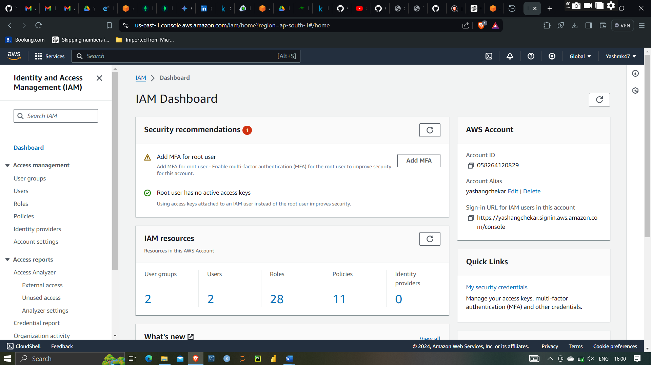

Clicking on Policy

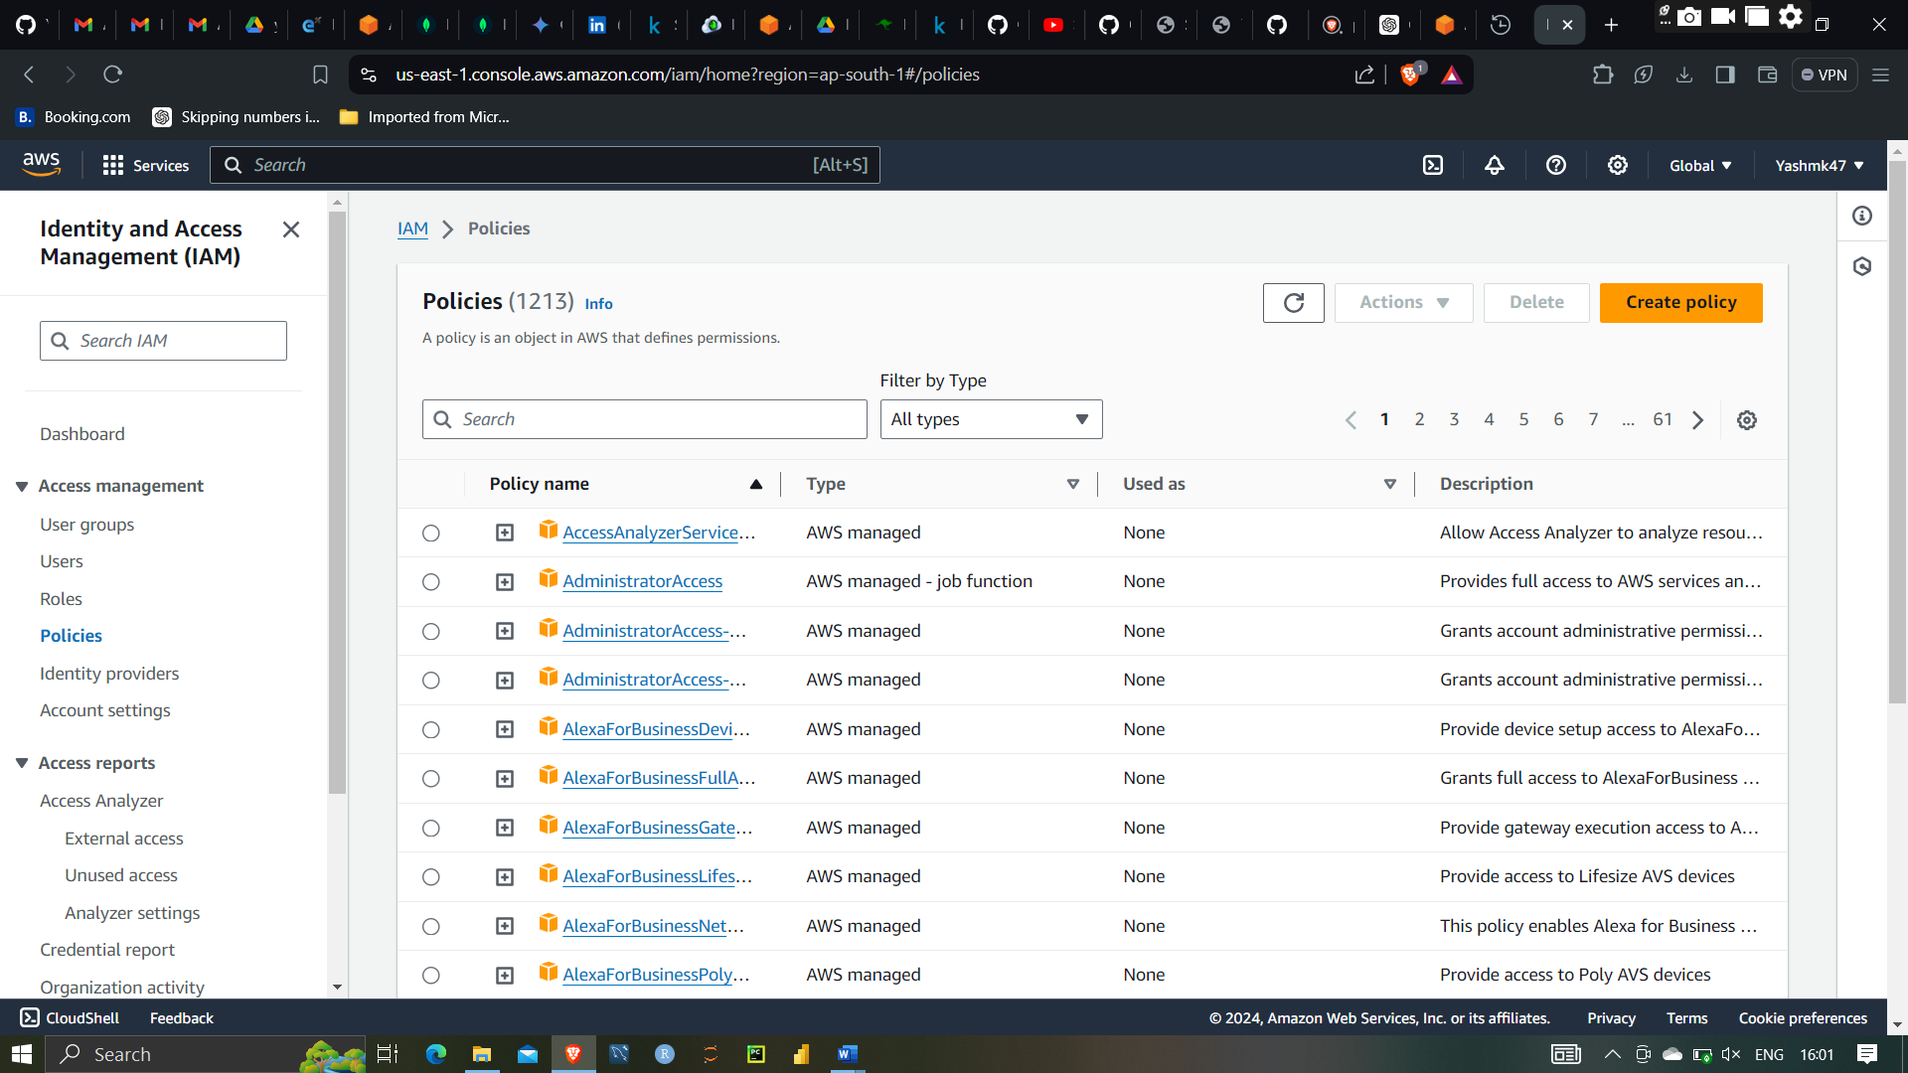

**Policies**: Policies are documents that define permissions. They can be attached to users, groups, and roles to grant or restrict their permissions. Policies are written in JSON format and can be managed in-line (attached directly to a user, group, or role) or managed (reusable and managed independently).

Create new policy

Selecting json tab and writing code in JSON format

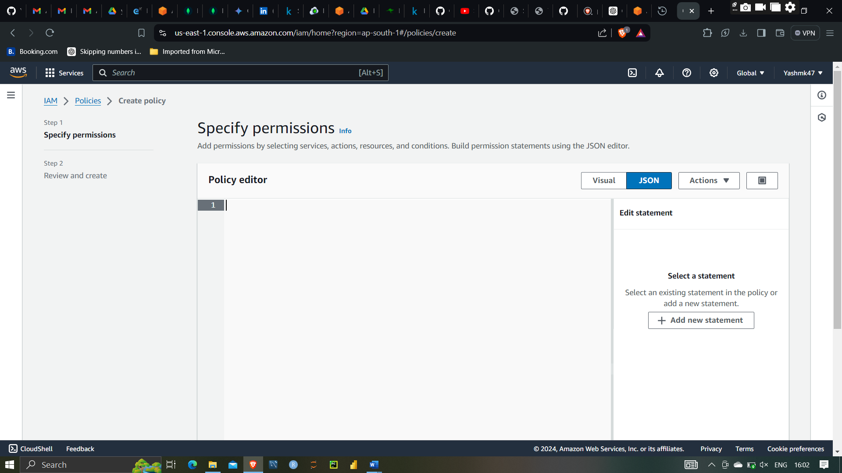

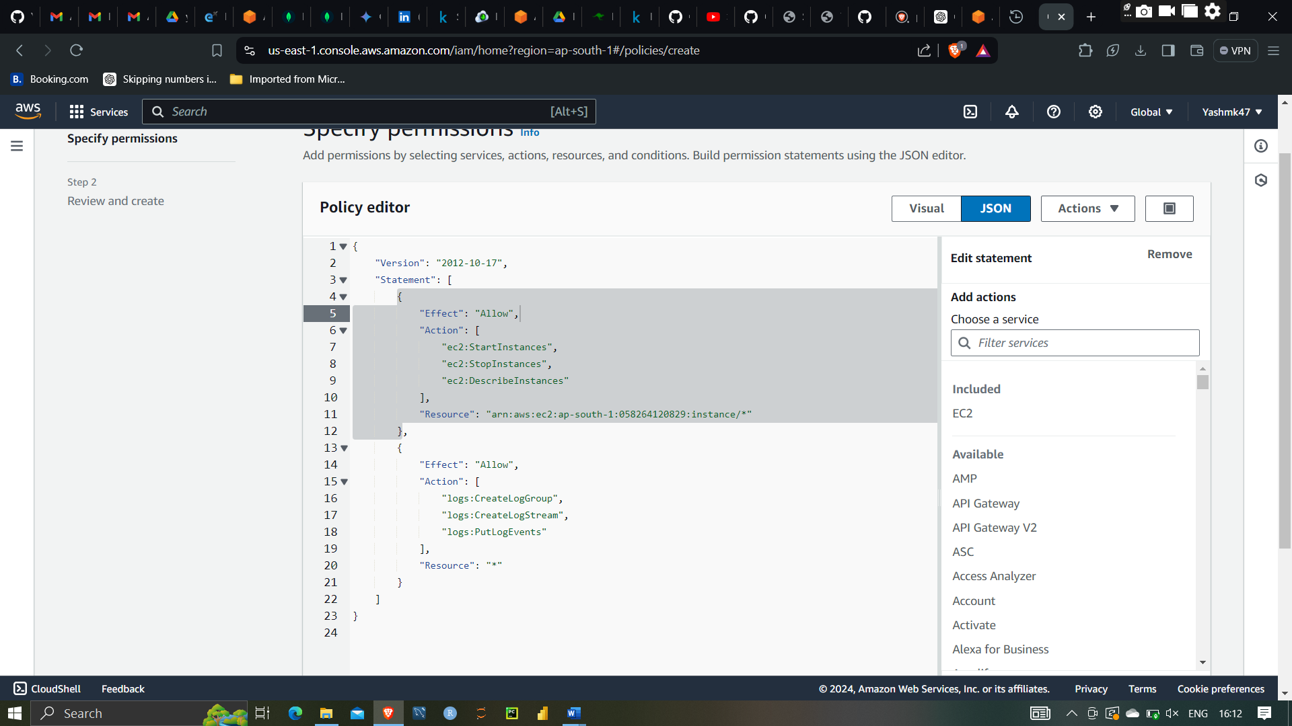

Creating Writing the JSON Policy With Ec2 start and Stop action

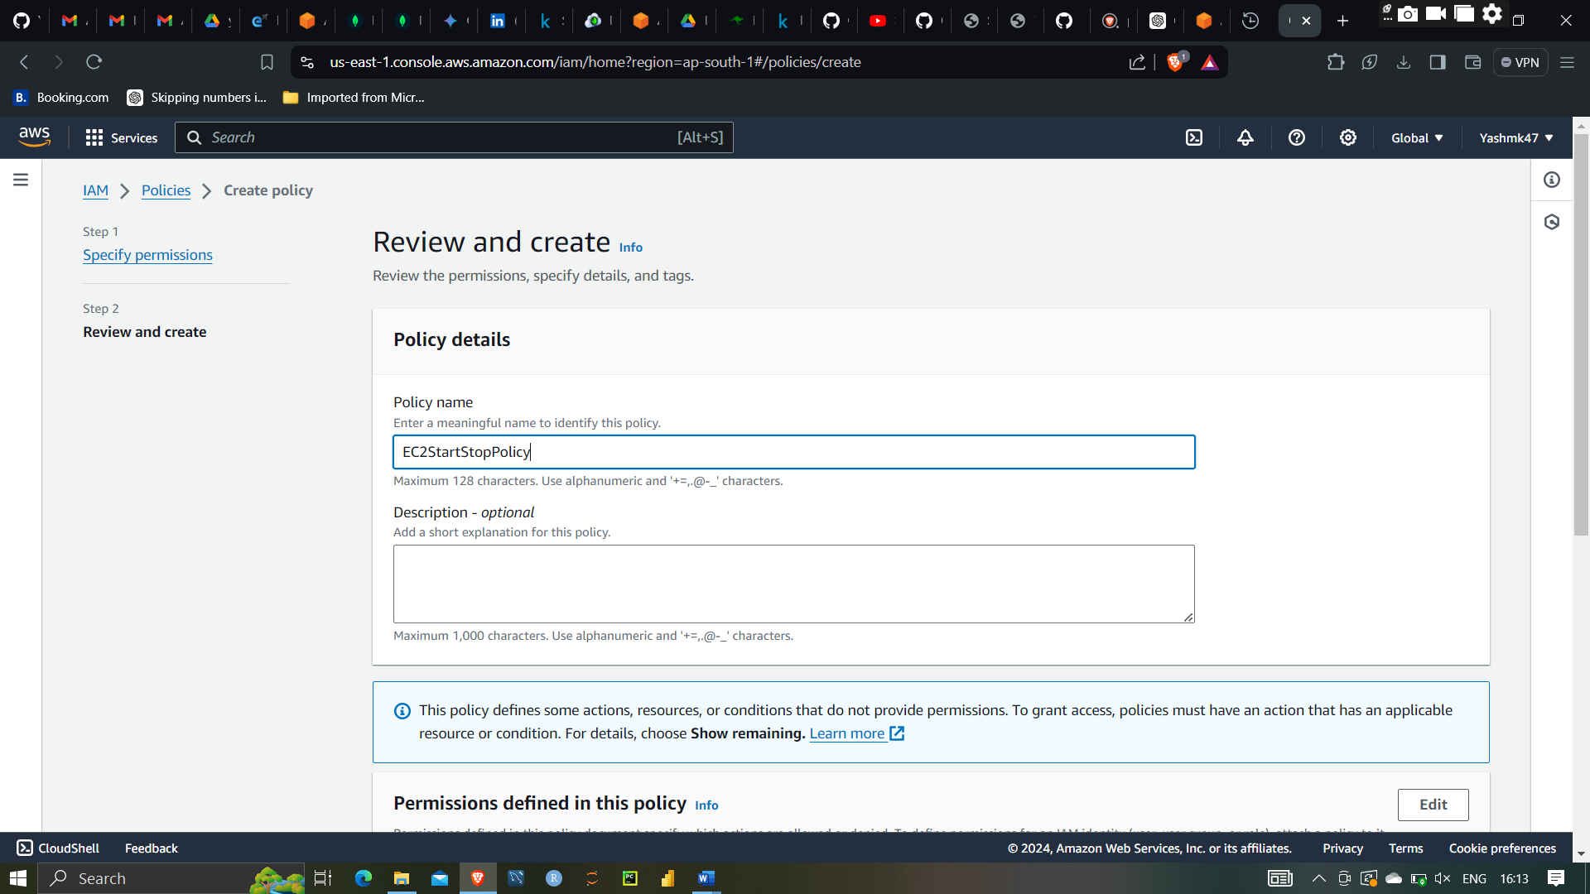

Creating EC2 Start and Stop policy

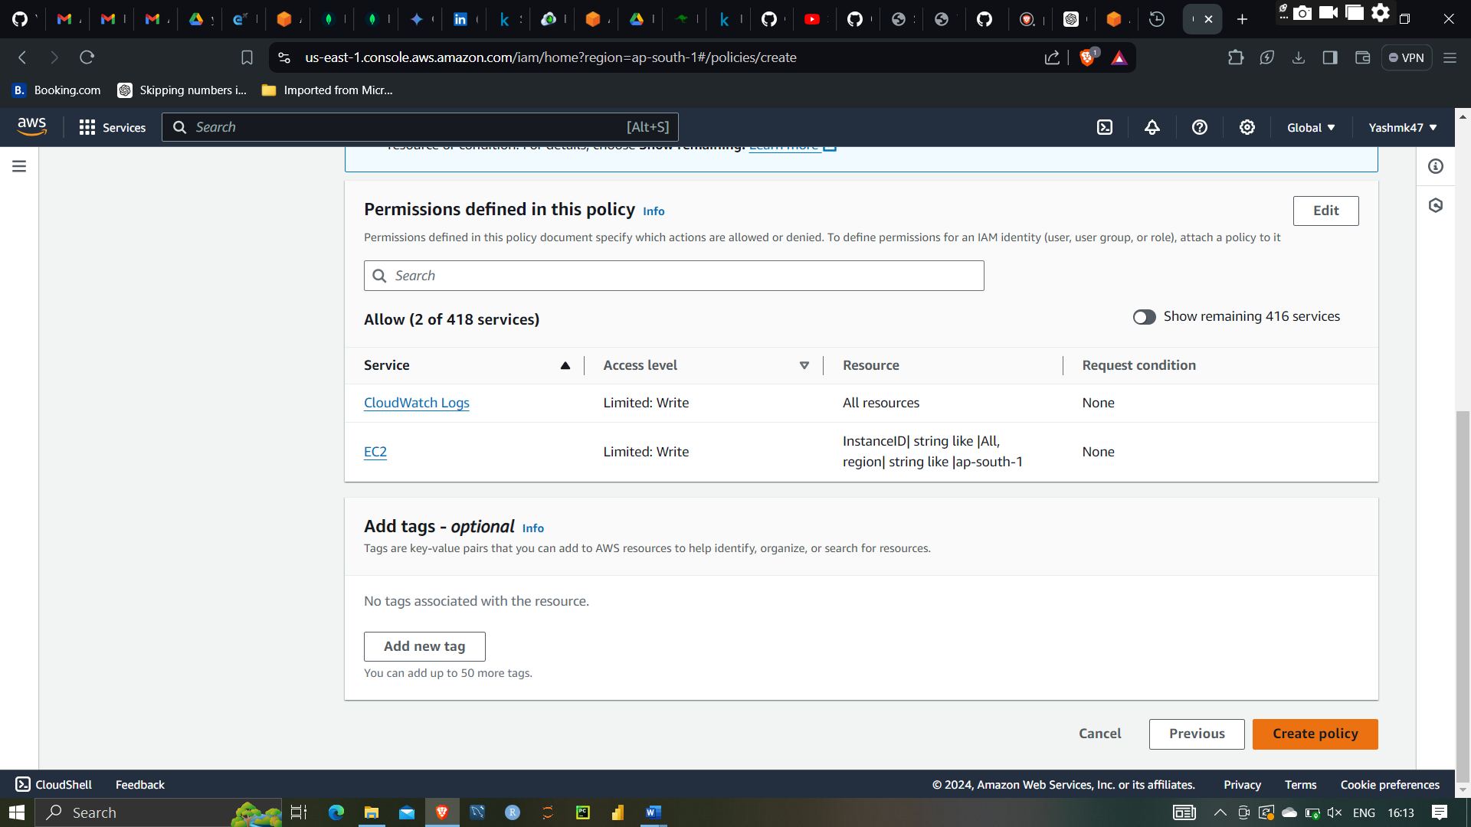

Succesfully showing start and stop policy

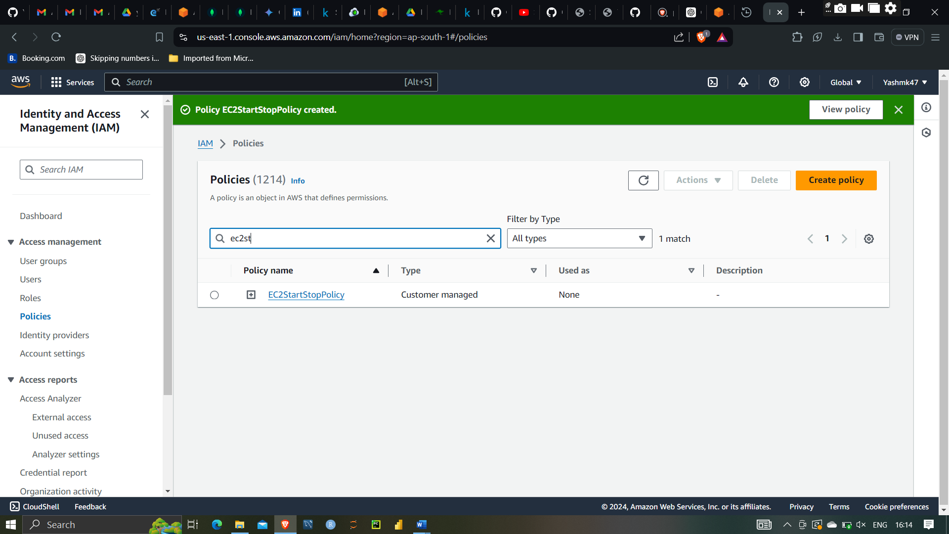

EC2 Start Stop policy created successfully

**Roles**: An IAM role is similar to a user in that it is an AWS identity with permission policies that determine what the identity can and cannot do in AWS. However, instead of being uniquely associated with one person, a role can be assumed by anyone who needs it. Roles are often used for granting temporary access to your AWS resources.

After that creating Role

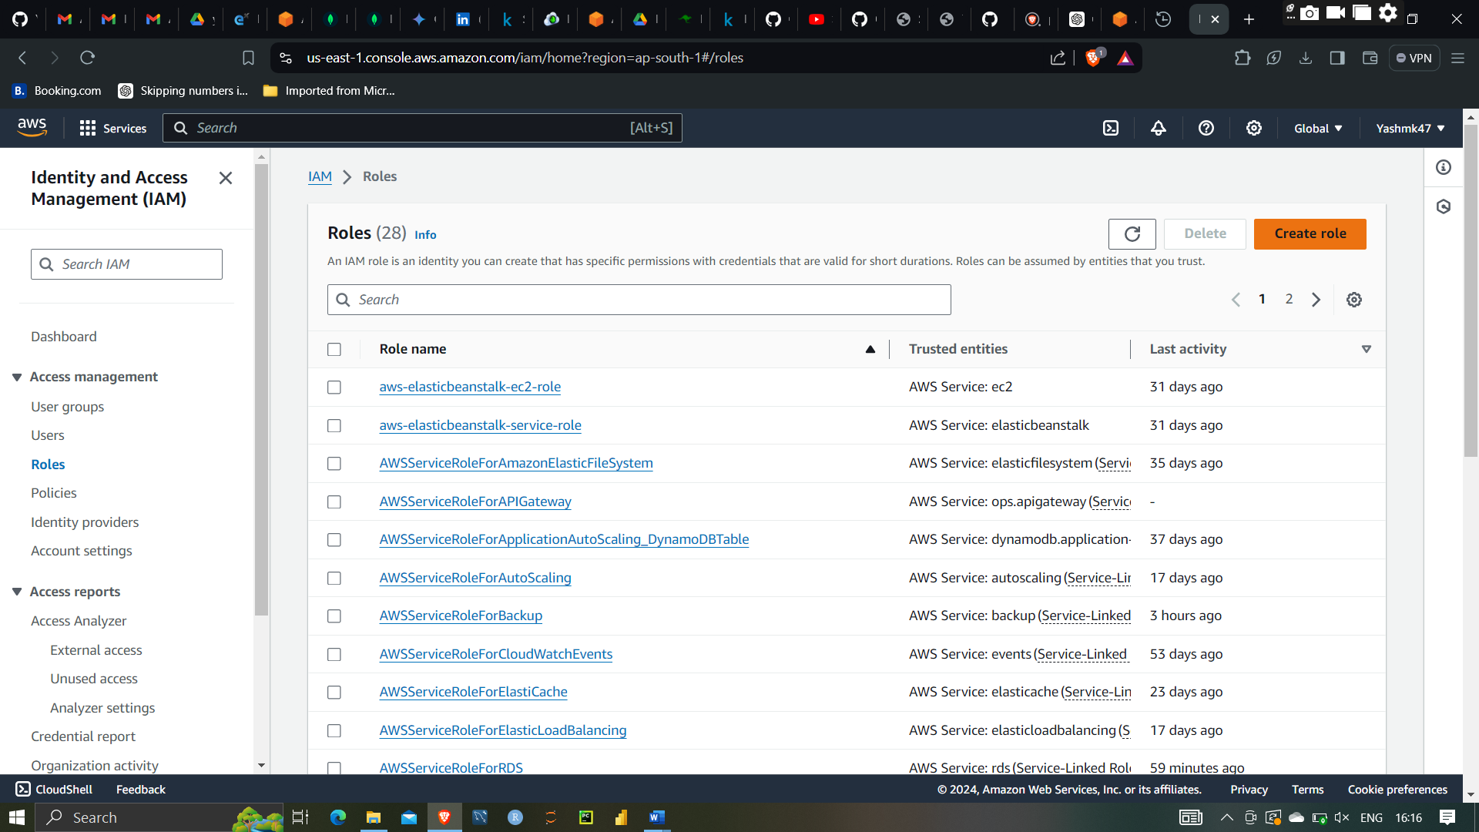after that creating Role

Selecting AWS service and Lambda service

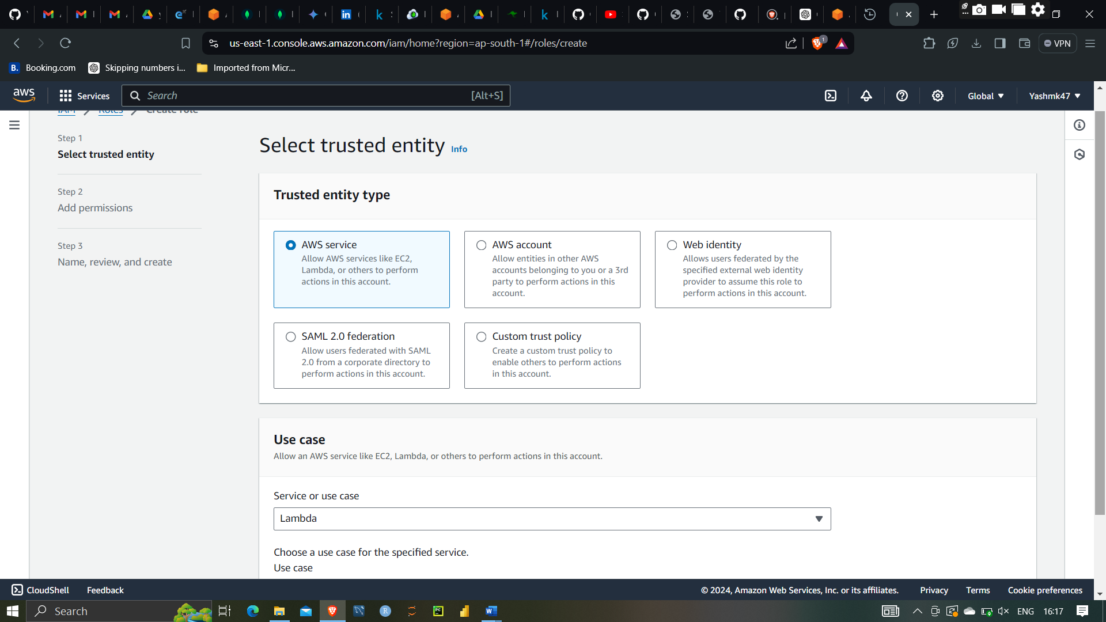

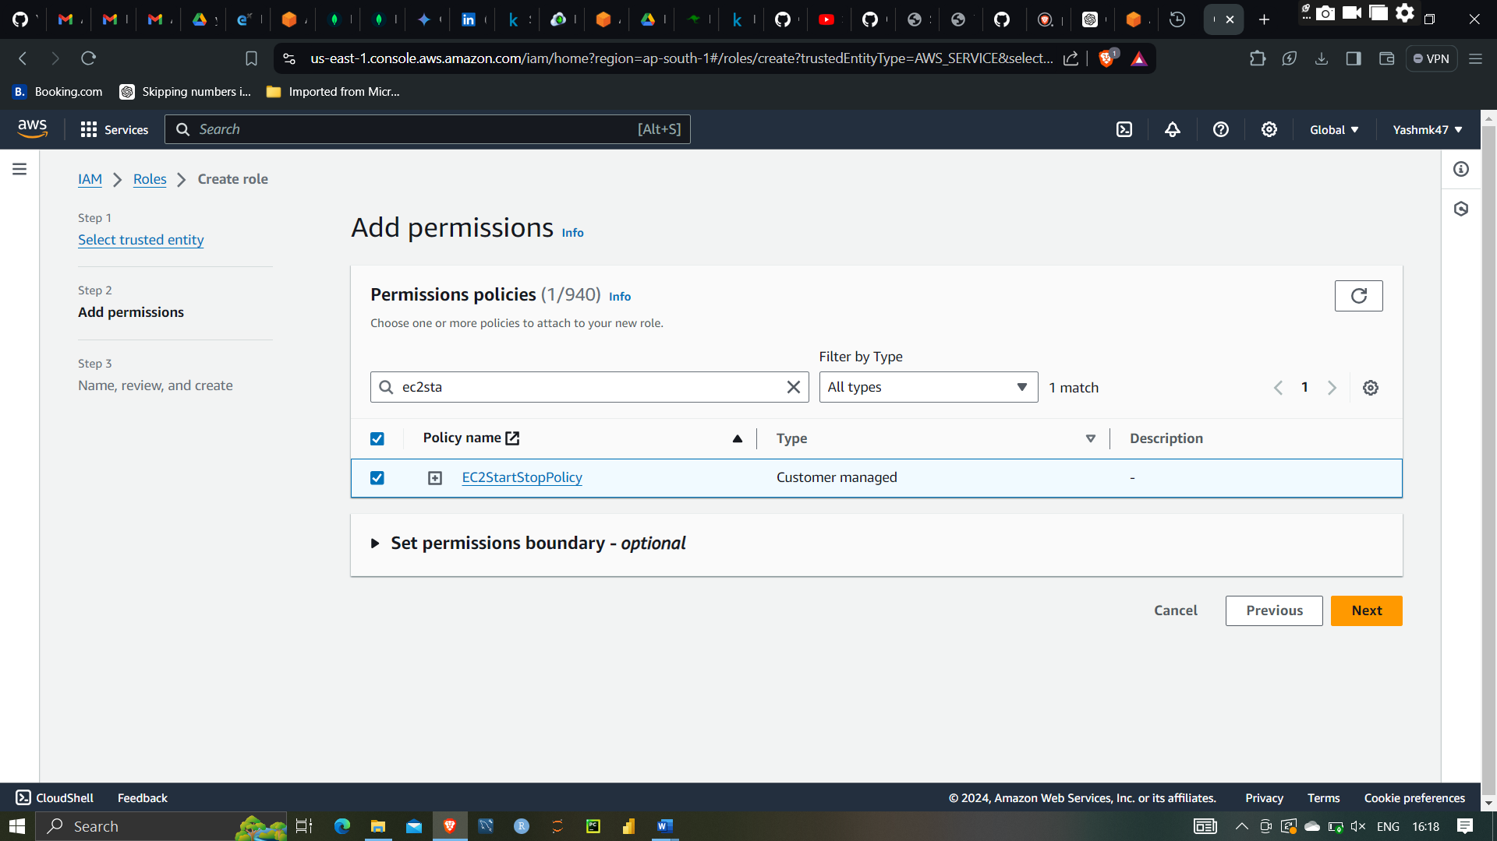

After that selecting start and stop policy

Giving name EC2 StartStopRole

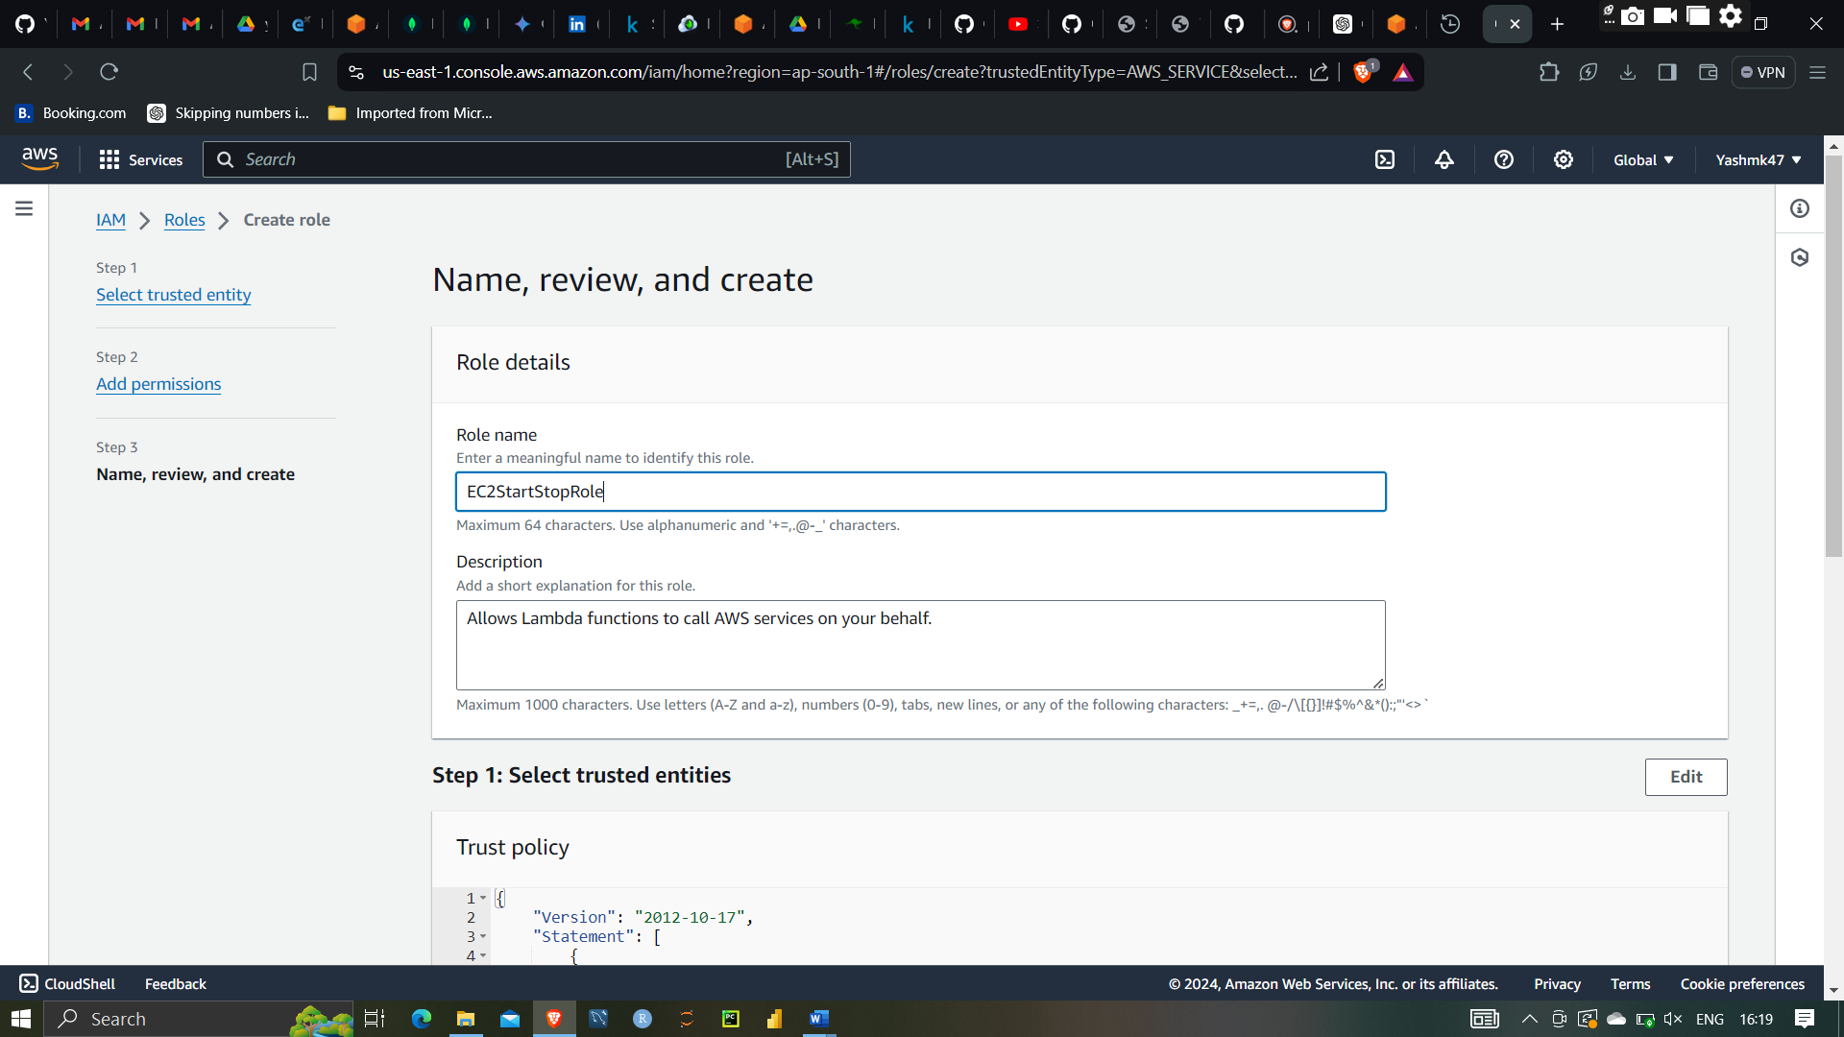

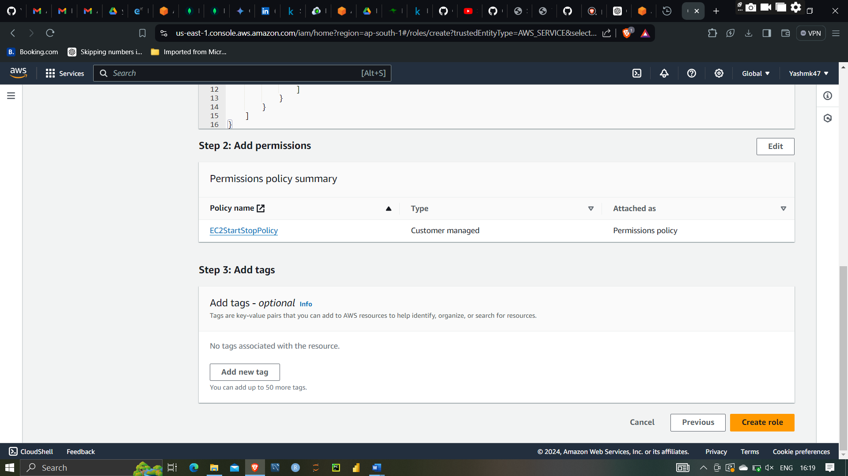

Clicking on create role

Role is created successfully

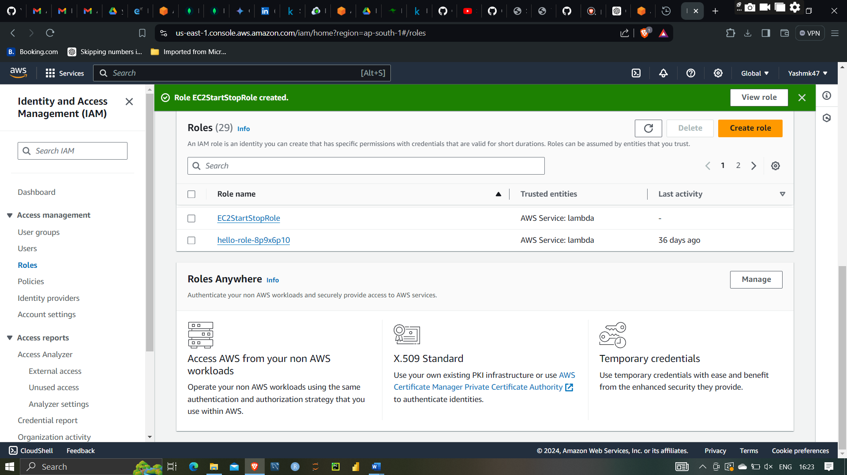

AWS Lambda is a serverless compute service that allows you to run code without managing servers. You simply upload your code, set up triggers, and Lambda handles the execution and scaling. It supports multiple languages, including Node.js, Python, Ruby, Java, Go, and .NET Core, making it flexible for various application needs.

Lambda is event-driven, meaning it can be triggered by events from other AWS services like S3, DynamoDB, and Kinesis, or through HTTP requests via API Gateway. This enables real-time data processing, automated backups, and the creation of scalable backends for web and mobile applications.

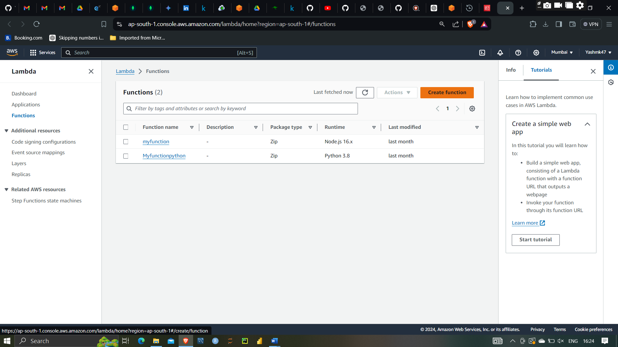

Creating function name Start EC2 Instances

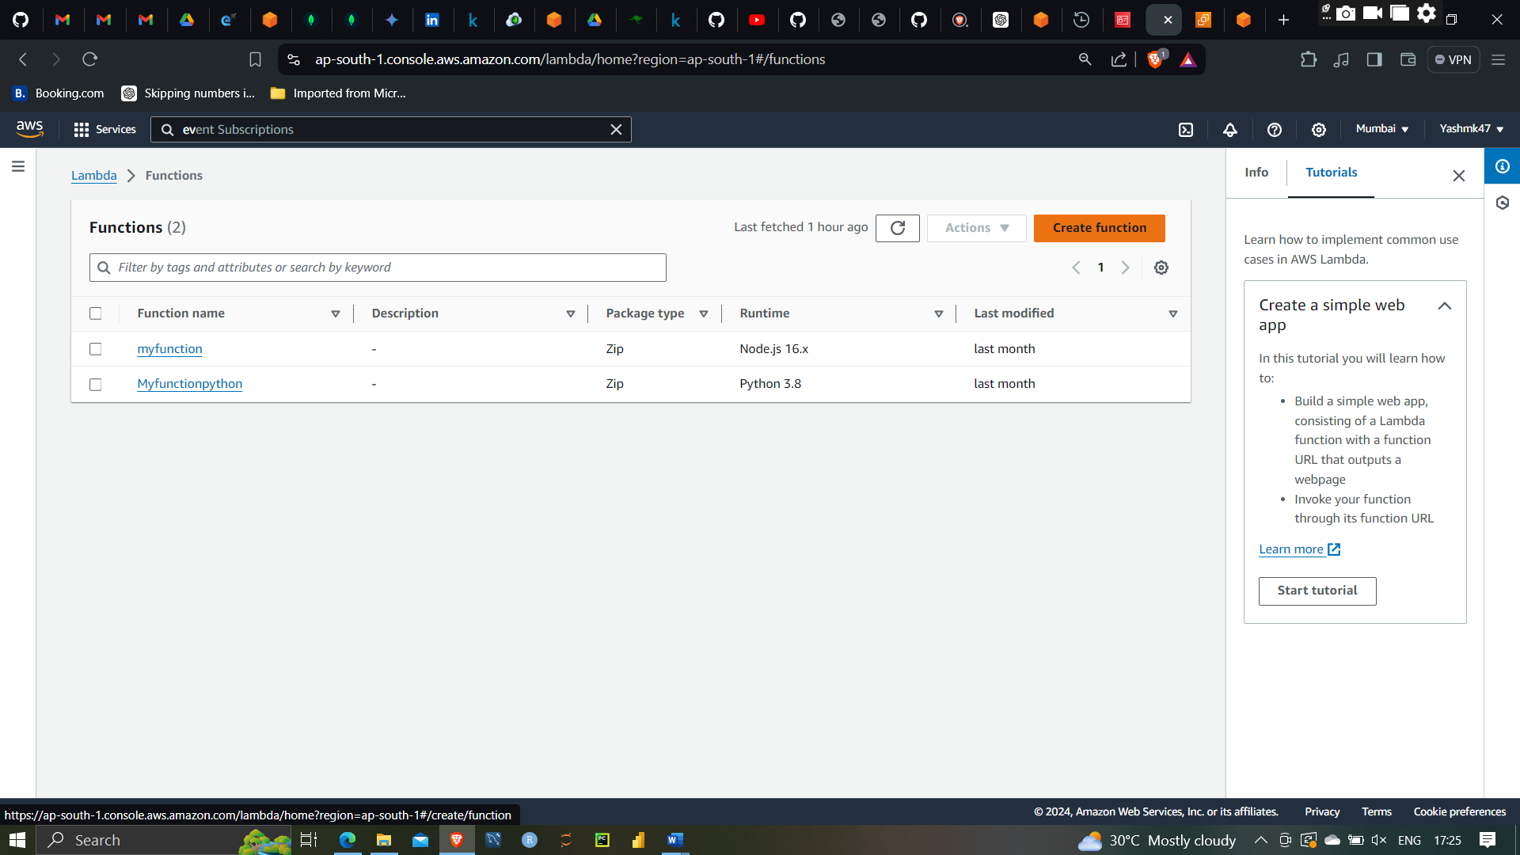

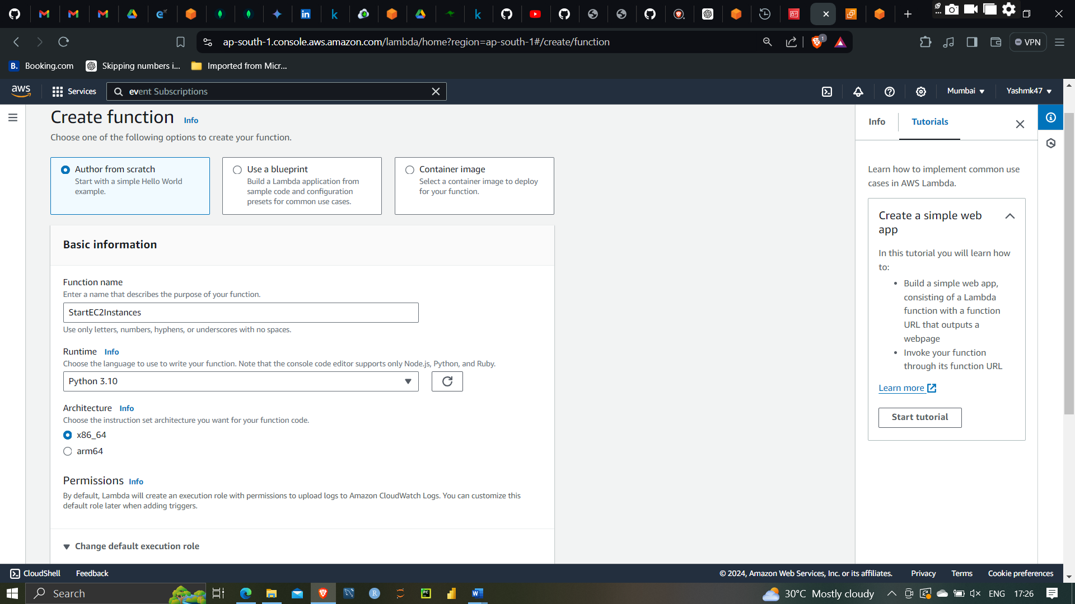

Creating Ec2 start function using python 3.10

And Attaching EC2StartStopRole

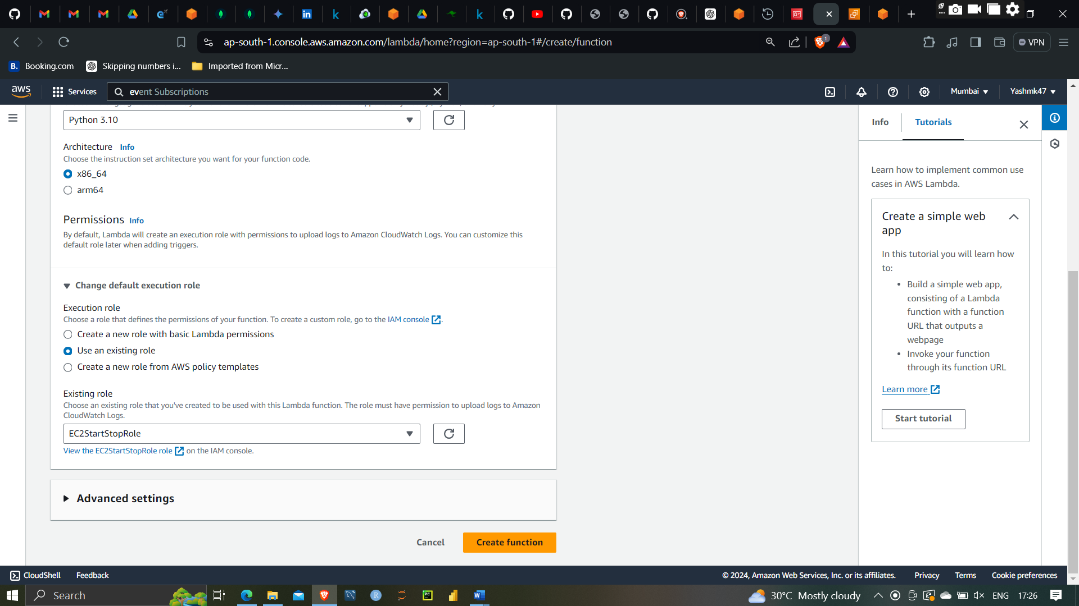

Attaching Ec2StartStopRole

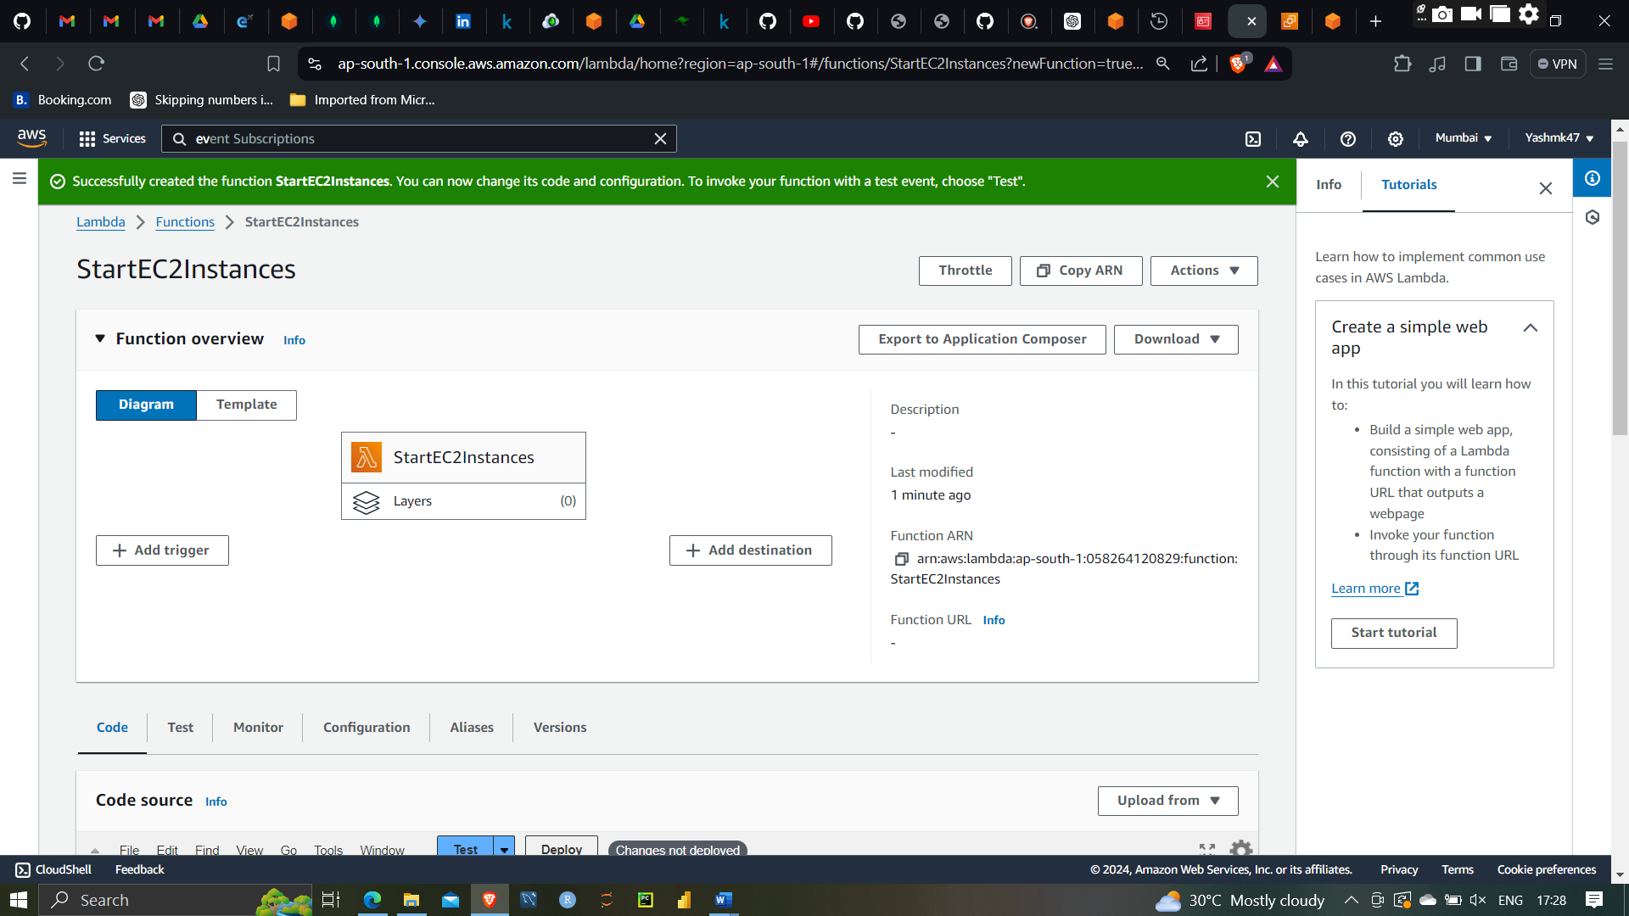

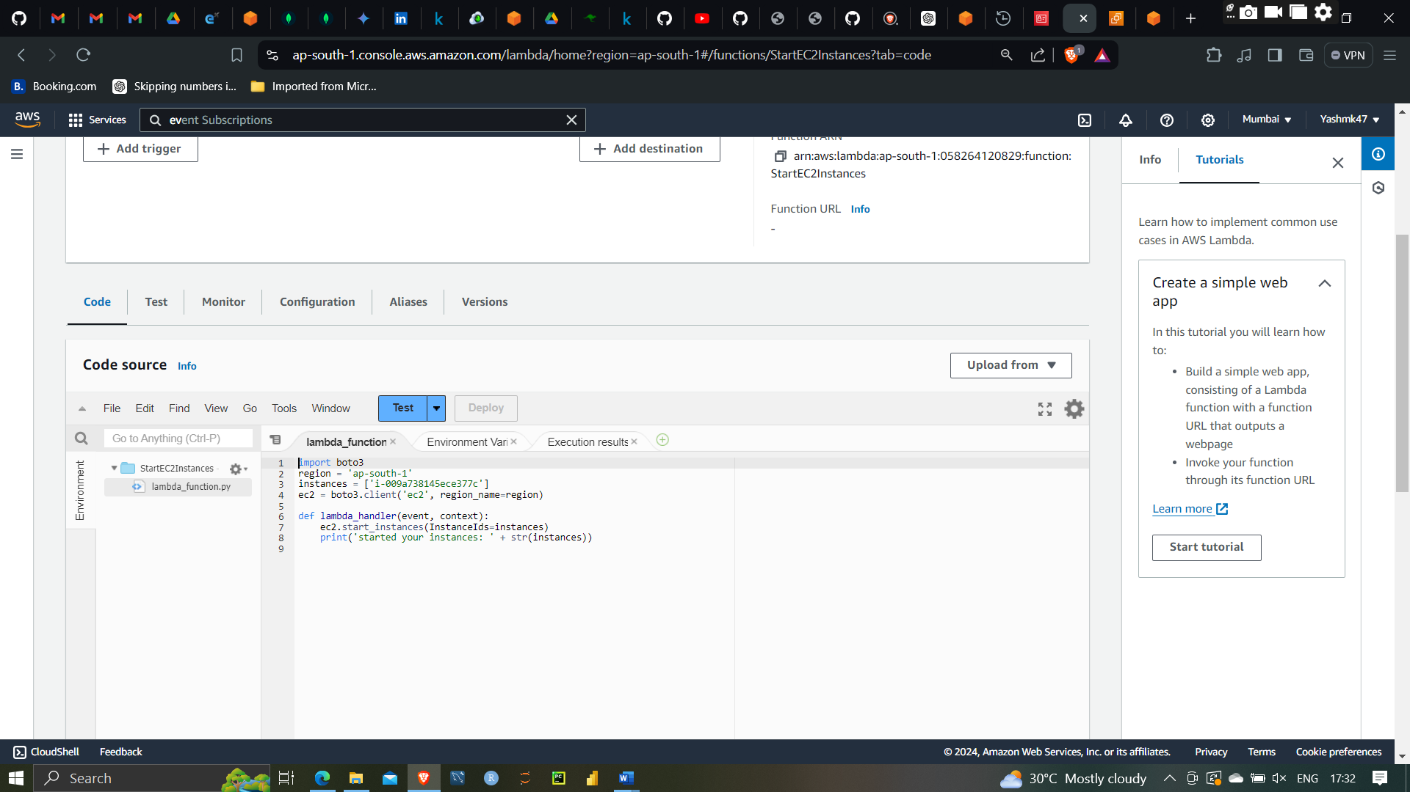

Writing function with Python code to start Ec2 instances I have created instances ‘id-009a738145ece377c’

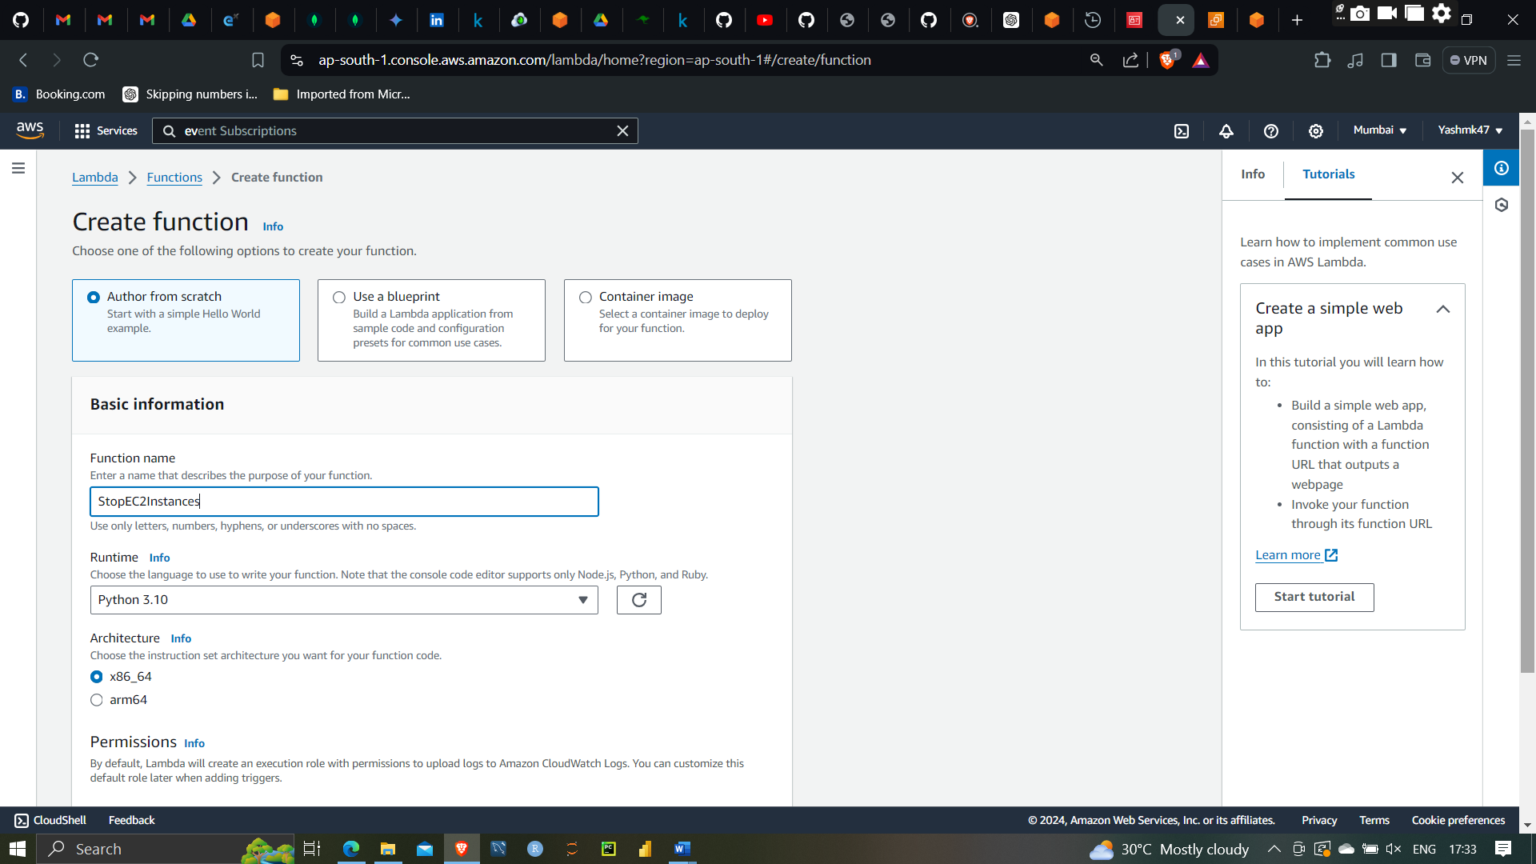

Creating StopEC2 instances with Selectin EC2 startstoprole

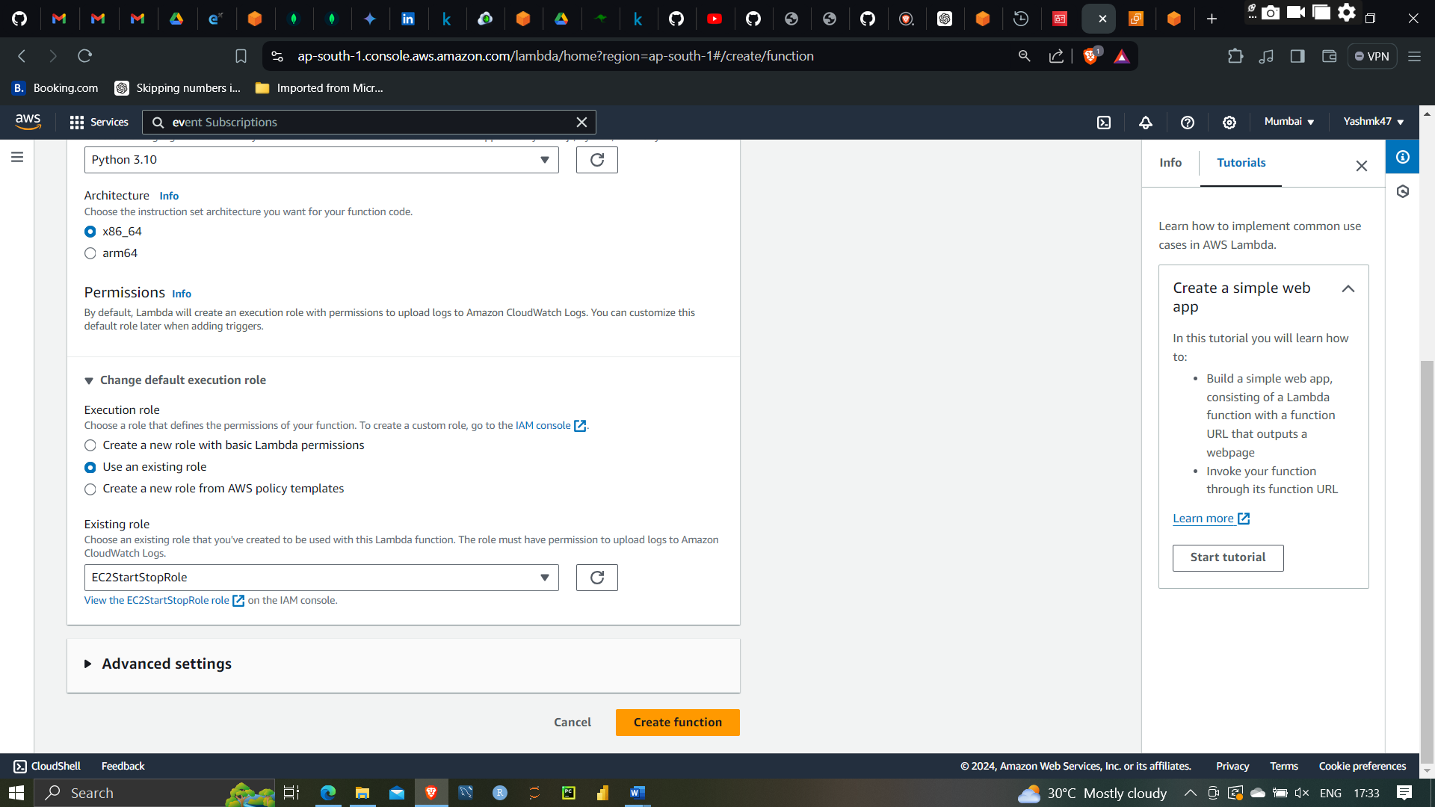

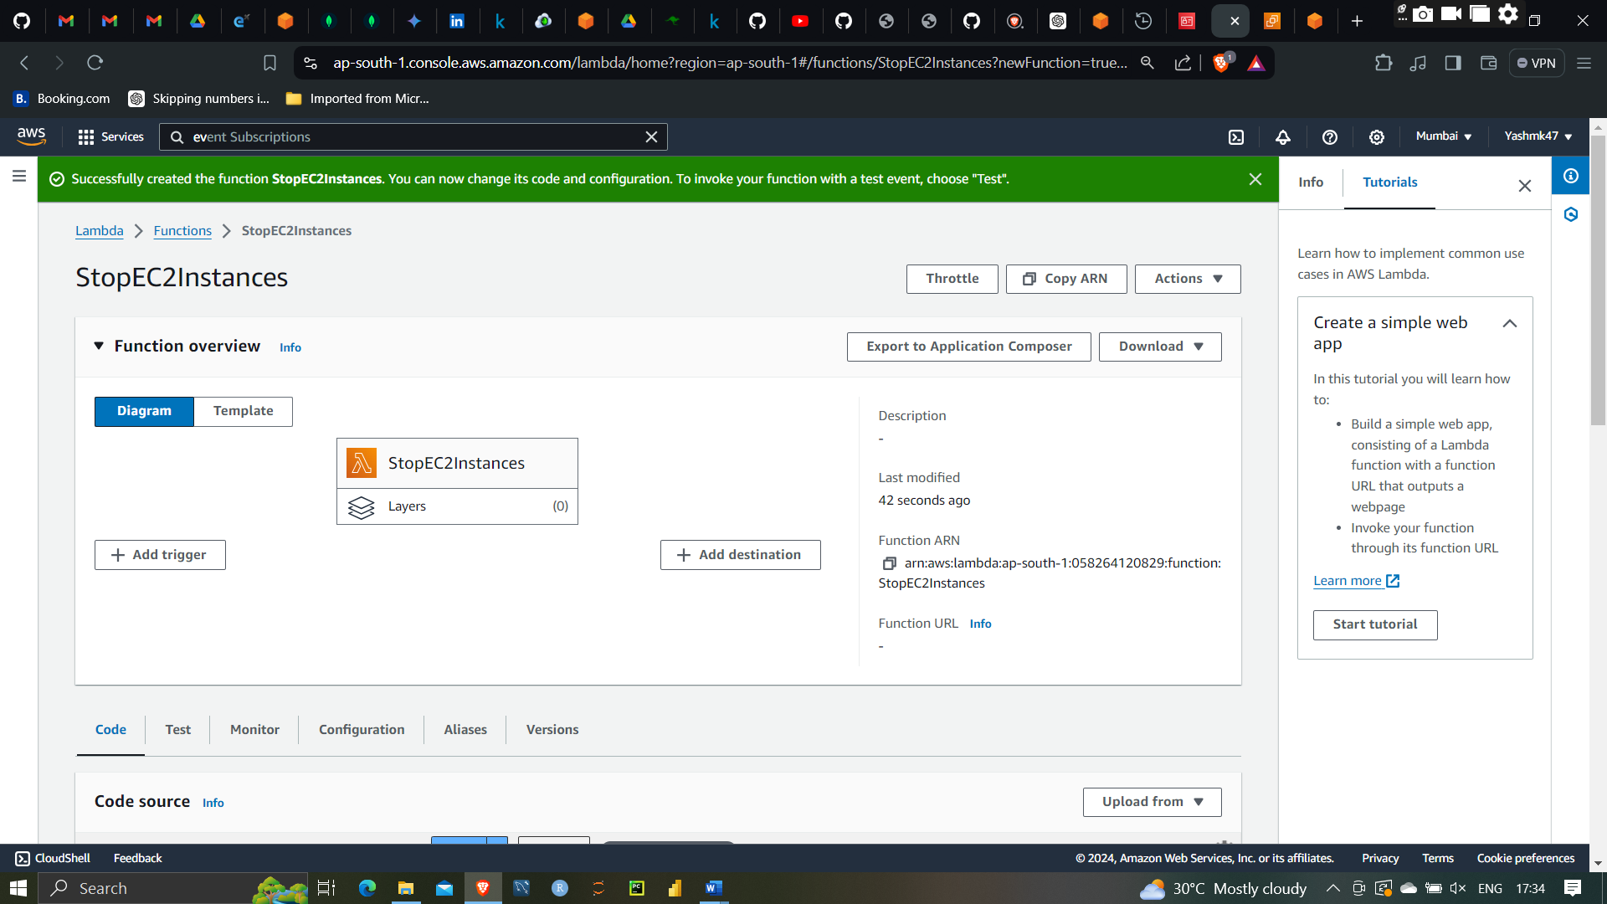

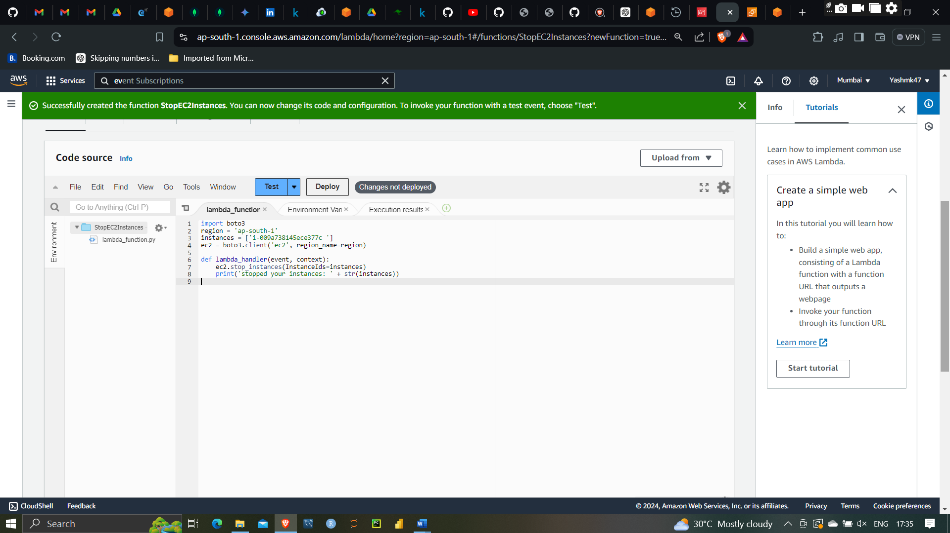

Write code in python to stop Ec2 instances

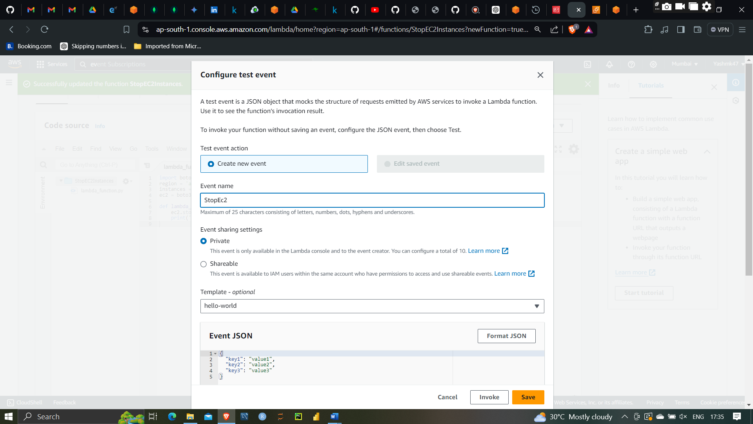

Saving the Function

Now we will test Weather Lambda is able start and stop the instances or not

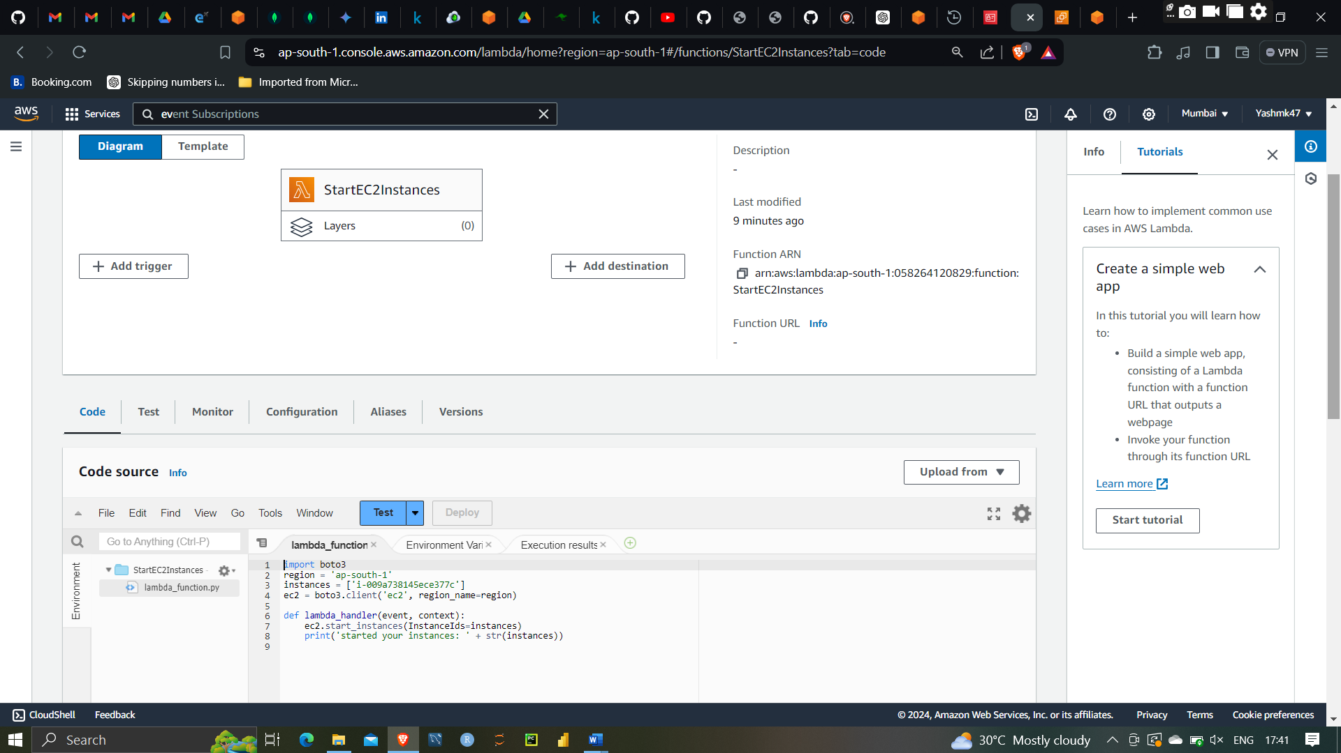

As you can see I am going to start instances which is stopped right now

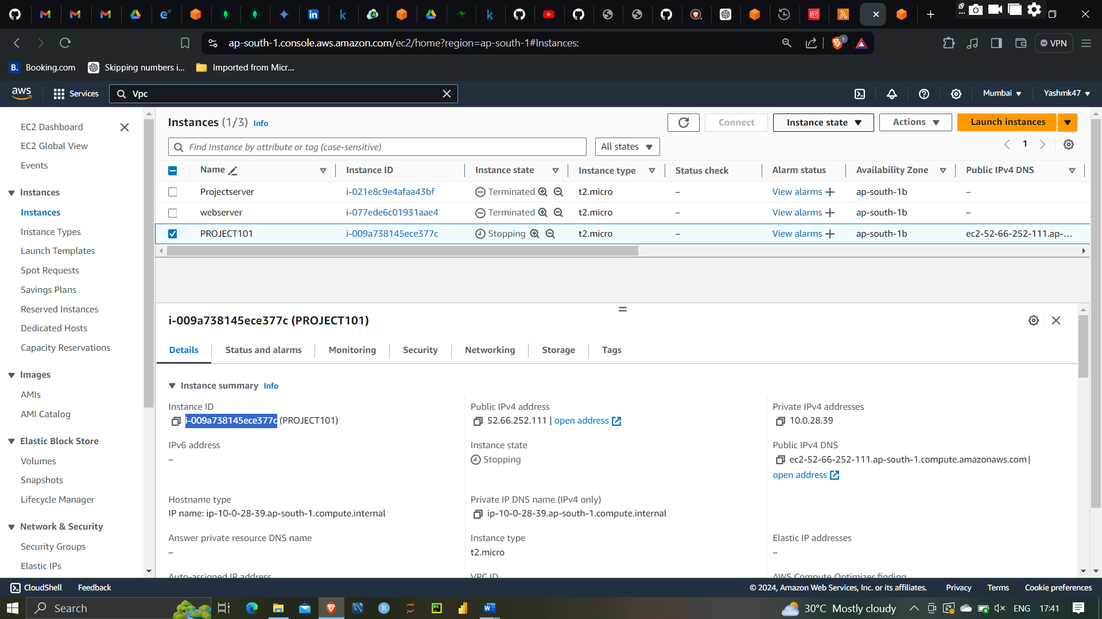

As you can see I am going to start instances which is stopped right now by clicking on test function

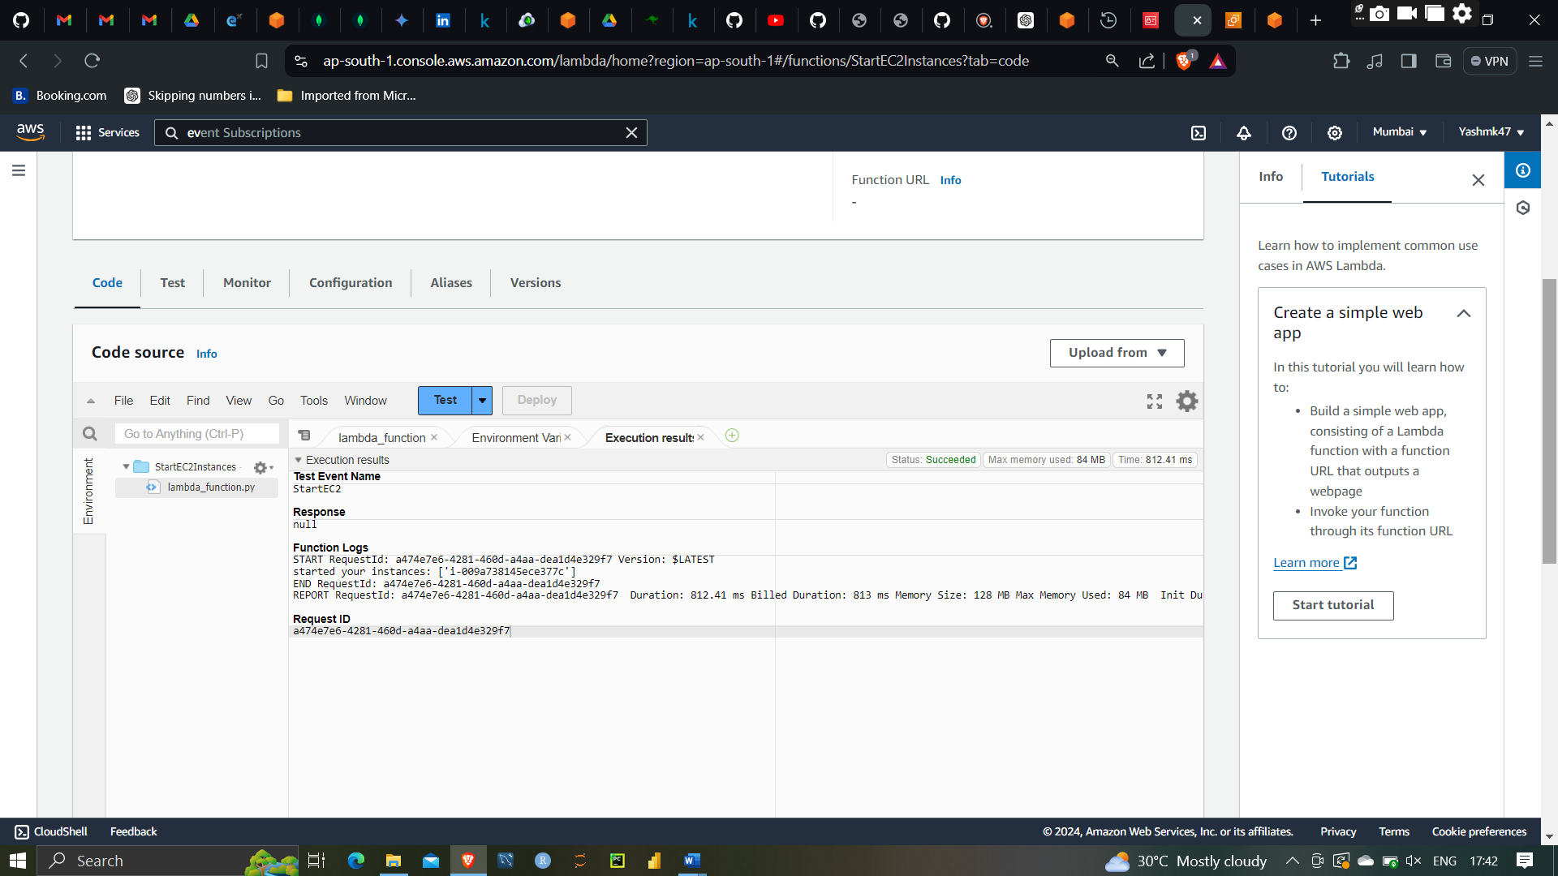

Code is excuted hences instances is start by using lambda start function

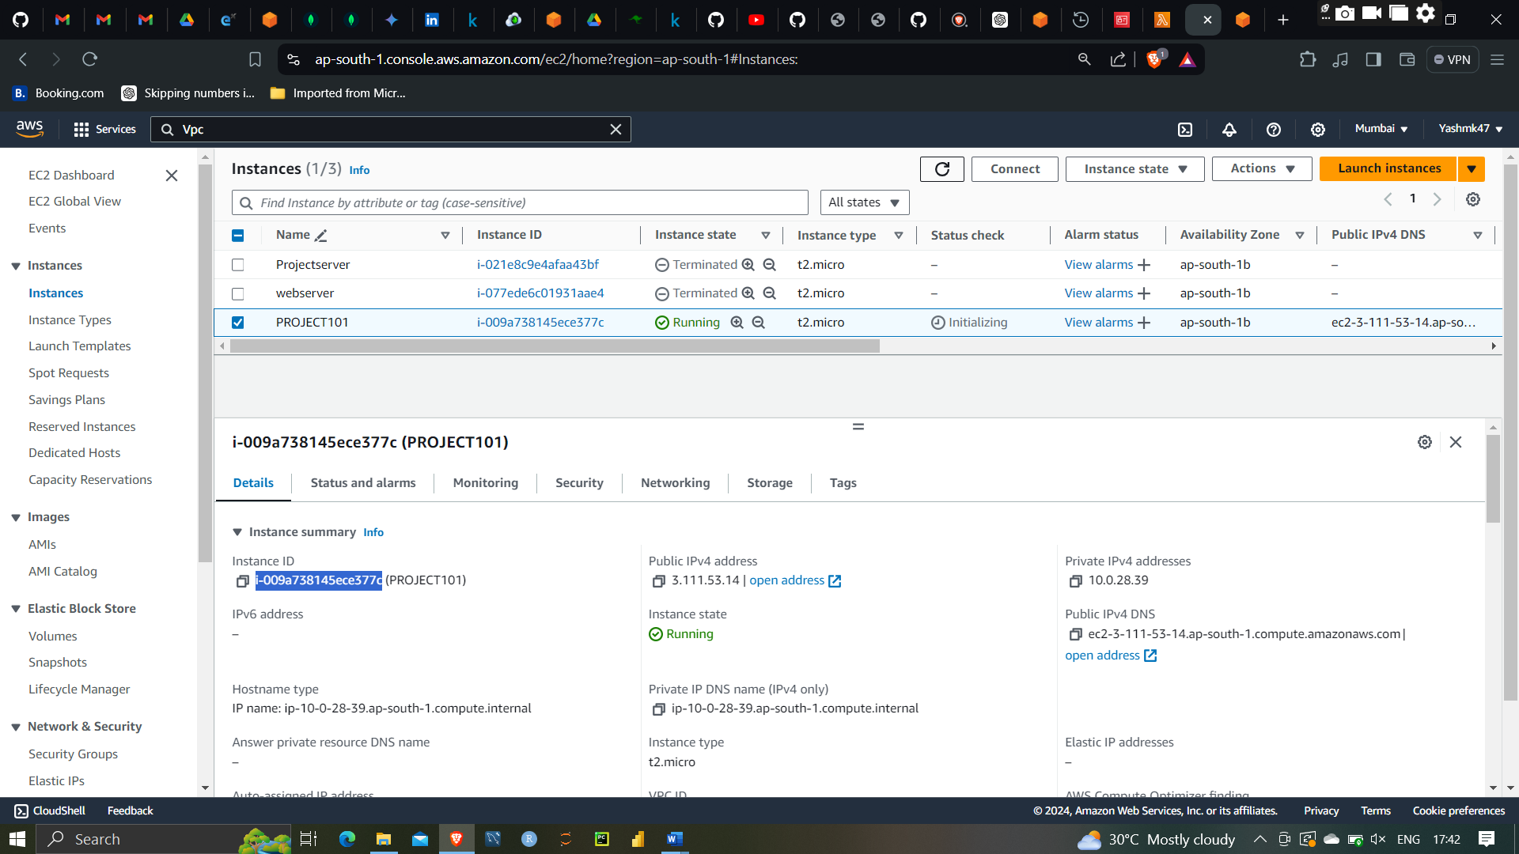

The instances is started

After that I am going to stop this instances using stopinstances function

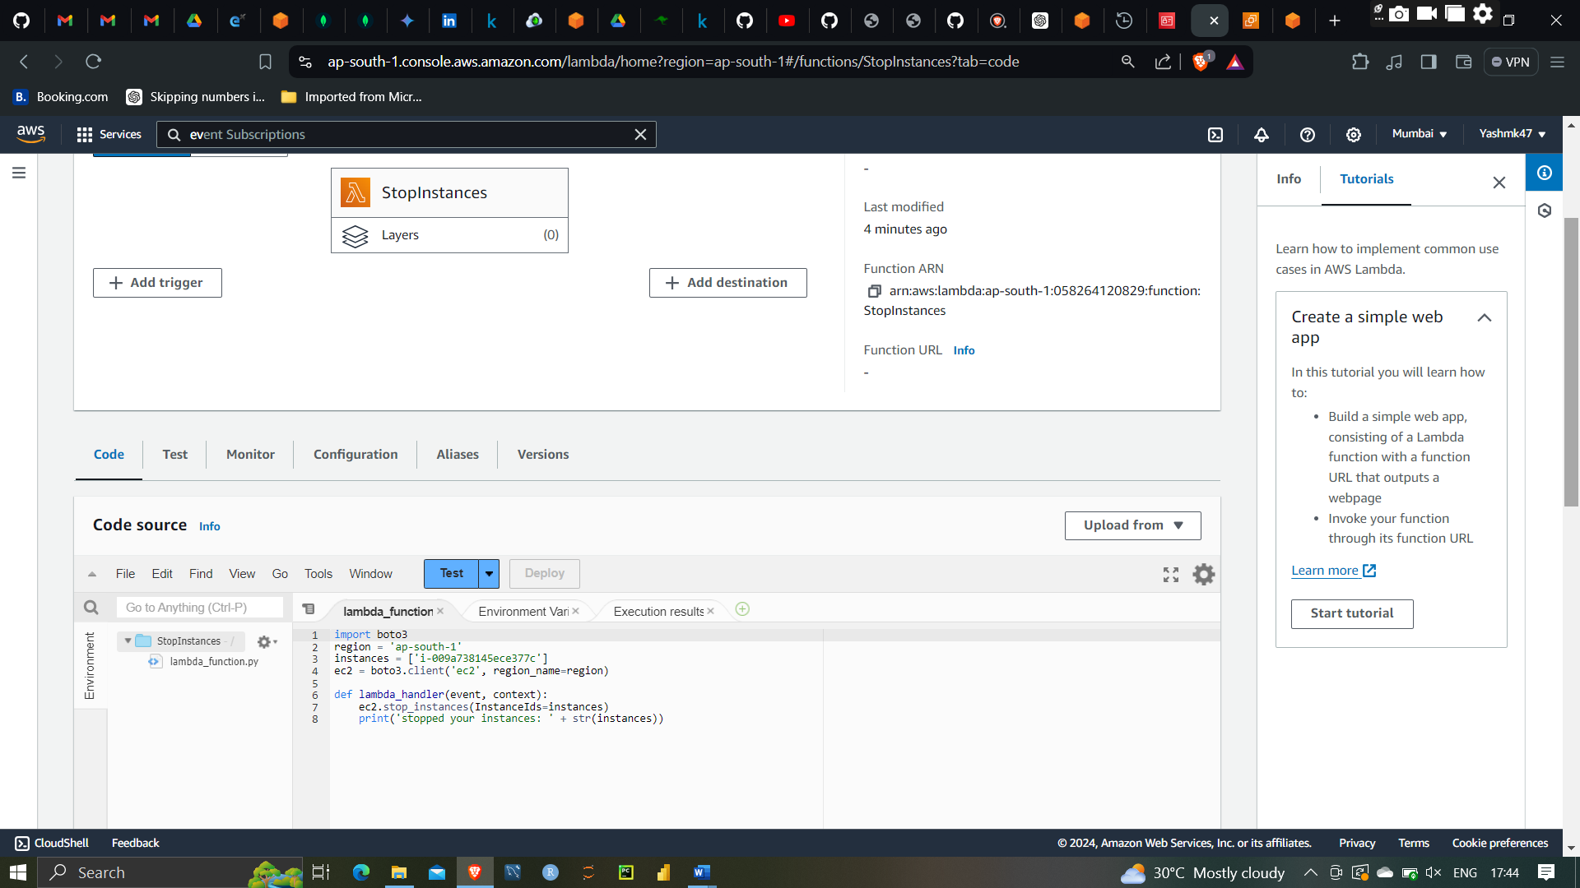

I am going stop instances with help of lambda stop function

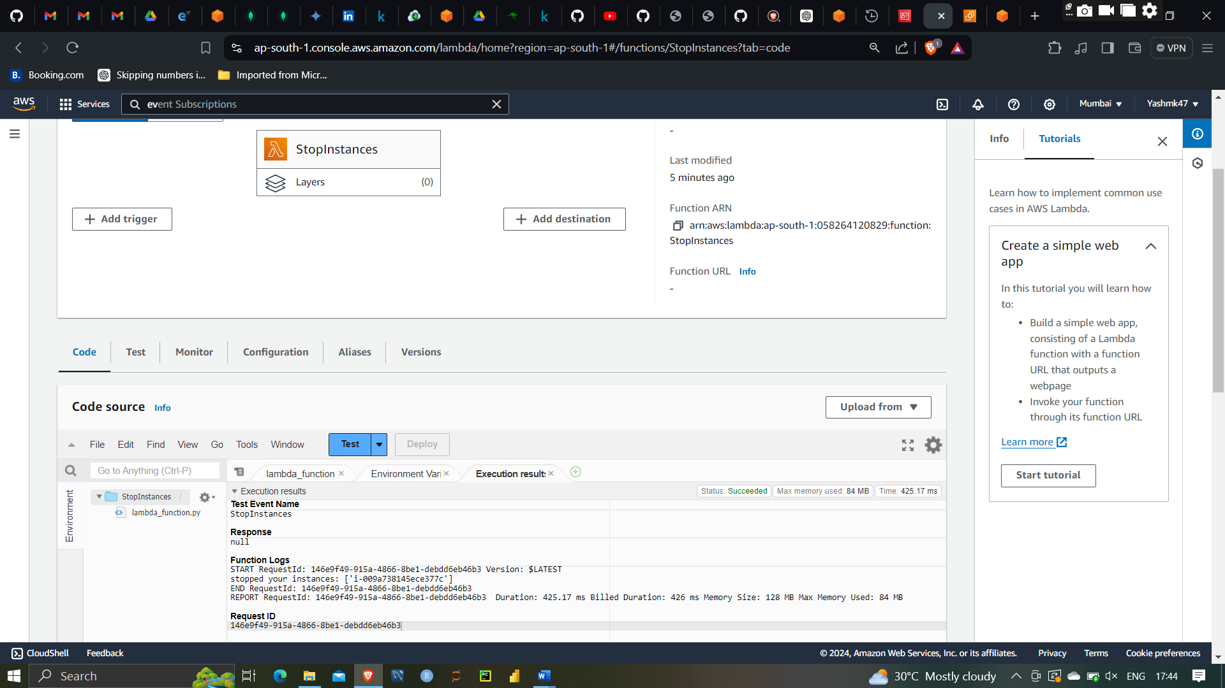

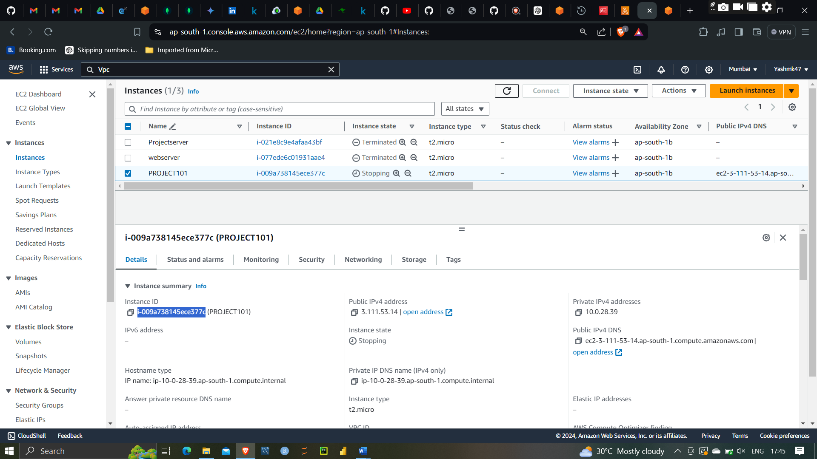

As you can the instances has stopped

SO I have automated start and stop instances by using Lambda and IAM user app by create Roles and Policy

AWS EventBridge is a serverless event bus service that enables you to connect applications using data from your own applications, integrated SaaS applications, and AWS services. It allows you to create event-driven architectures that respond to state changes and events in real time.

EventBridge can ingest, filter, and route events from various sources to different AWS services and custom targets, such as Lambda functions, Step Functions, and SNS topics. This capability helps you build scalable, loosely-coupled applications by decoupling the event producers from the event consumers.

Create EventBridge Rules that Run Your Lambda Functions on a Schedule

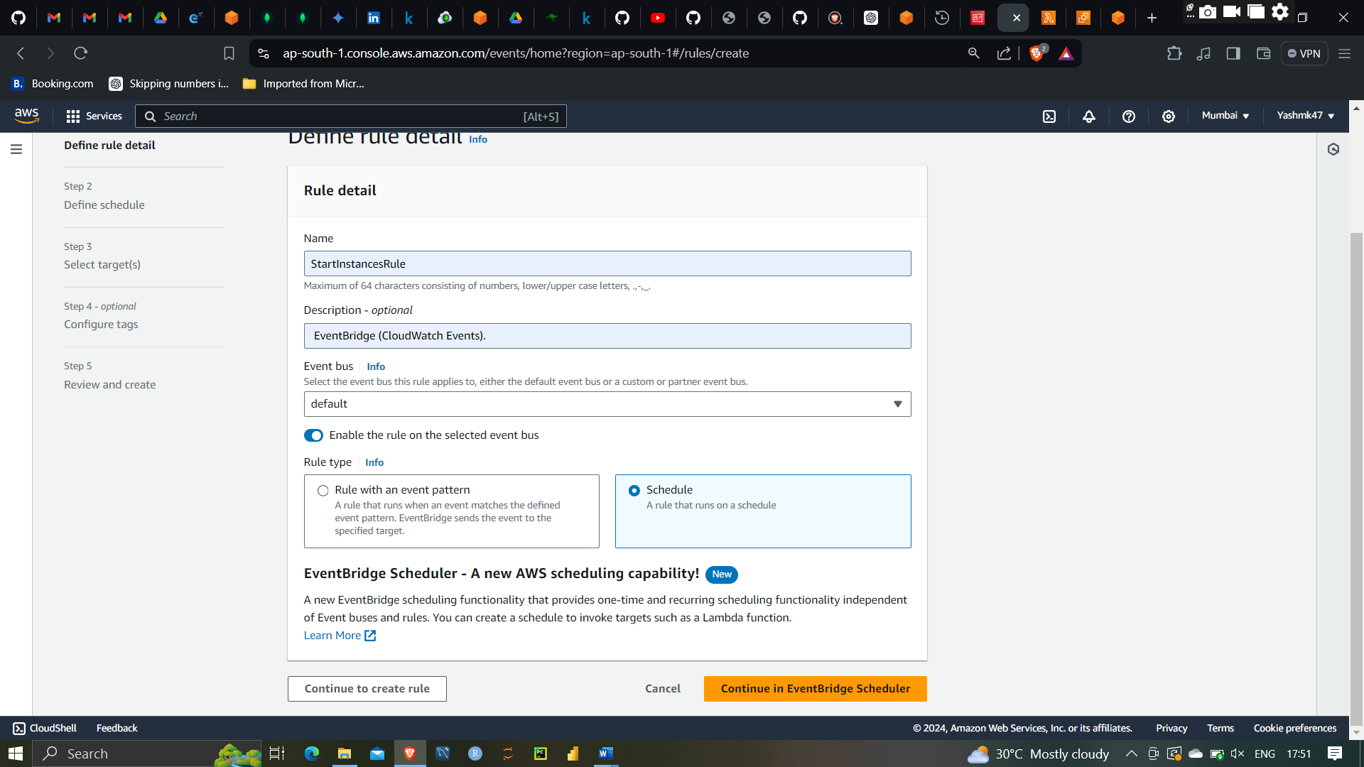

Scheduling the event at 6:17

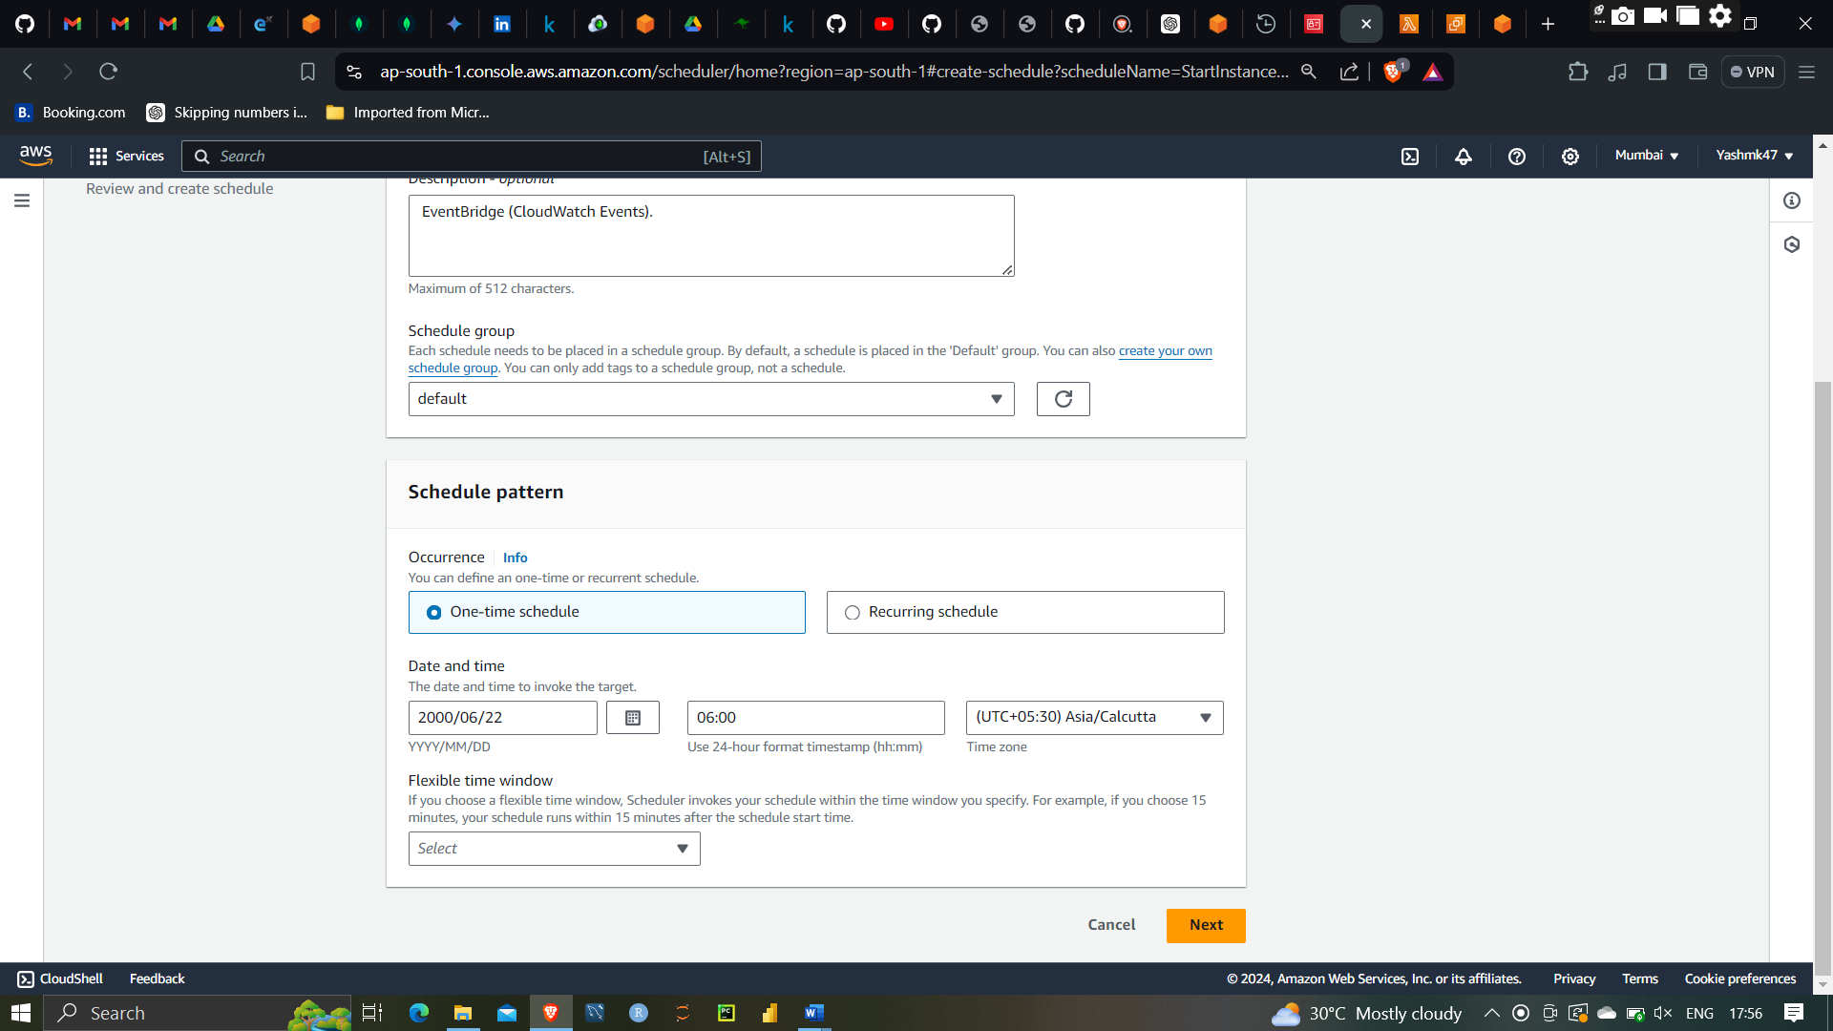

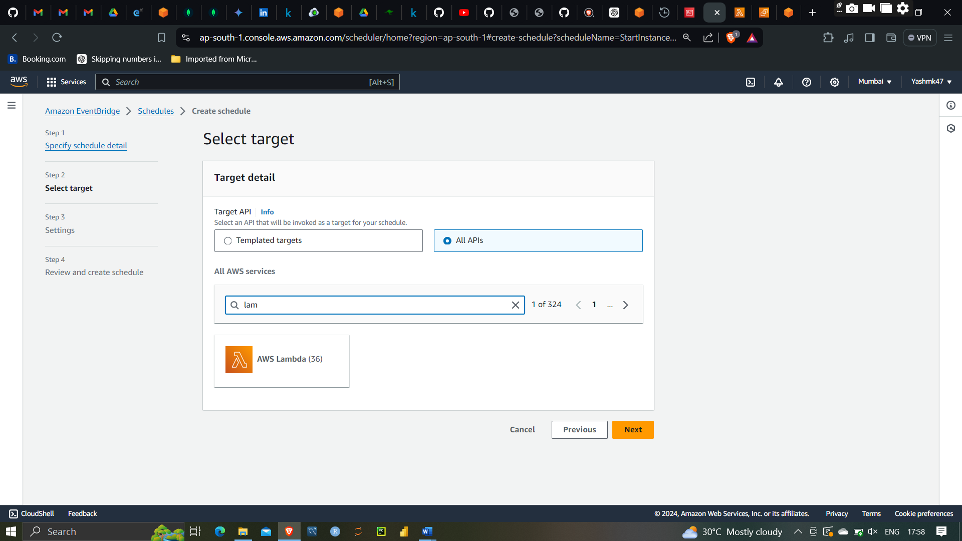

Selecting lambda function lambdafunction invoke

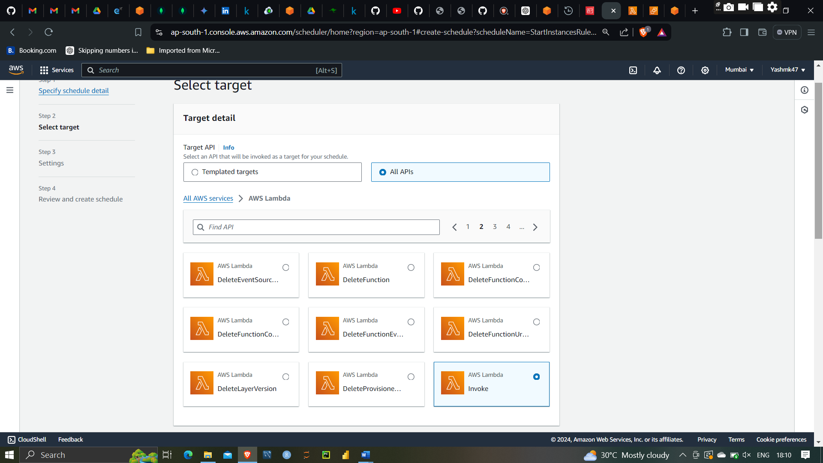

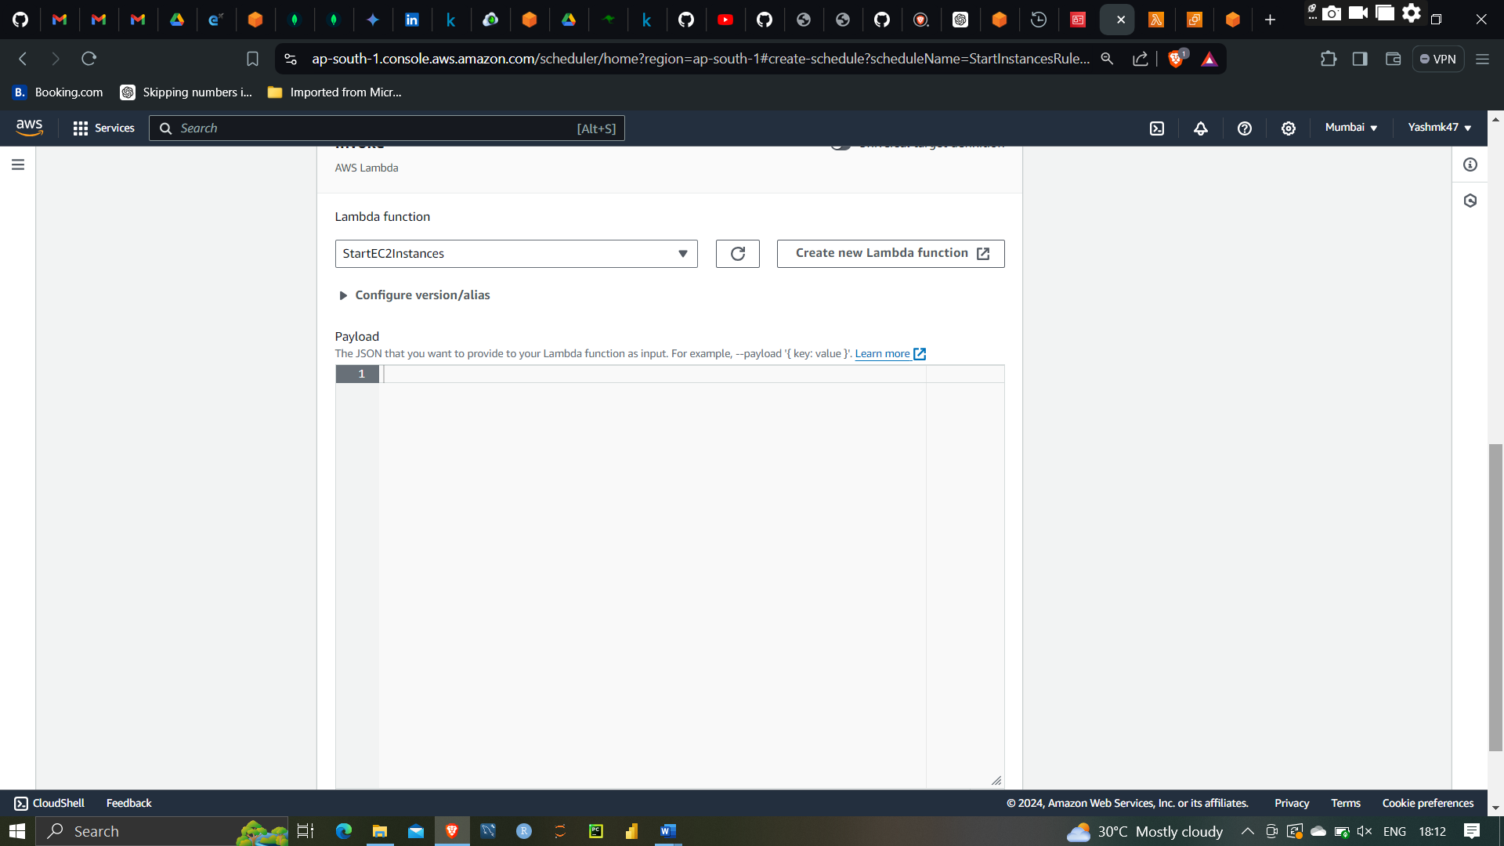

Selecting Lambda startEC2 instances

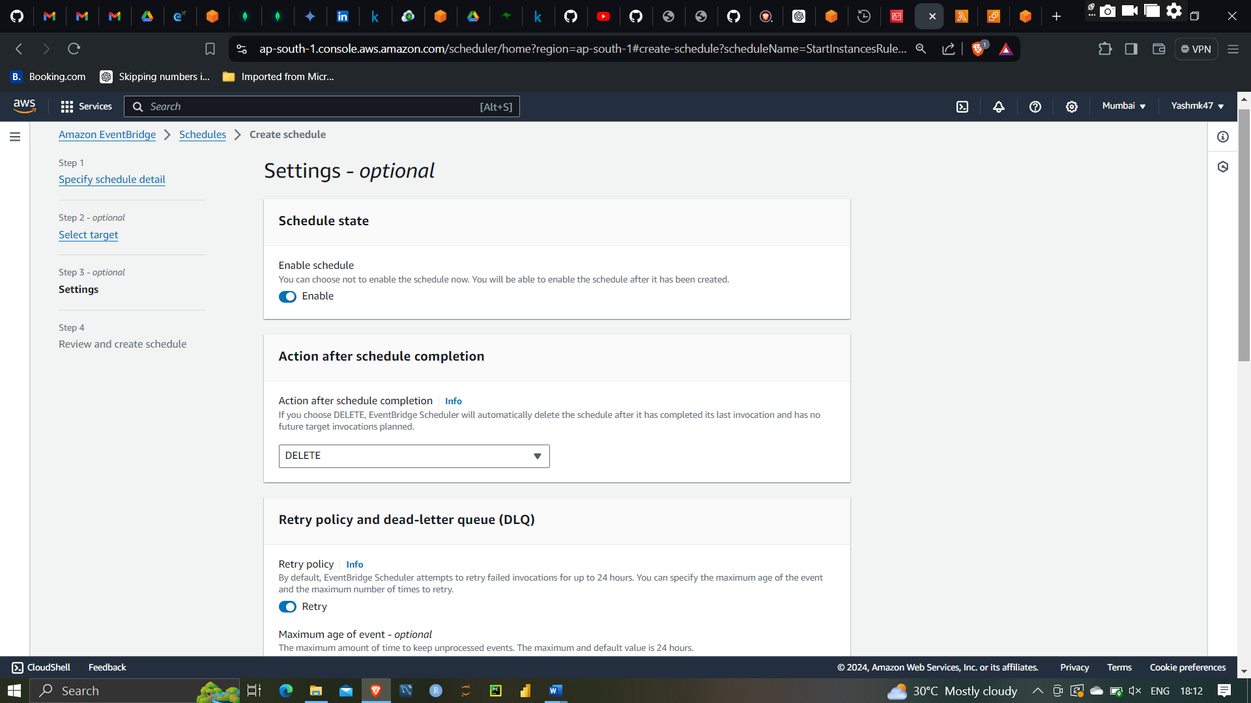

Enabling Schedule and once complete it is deleted

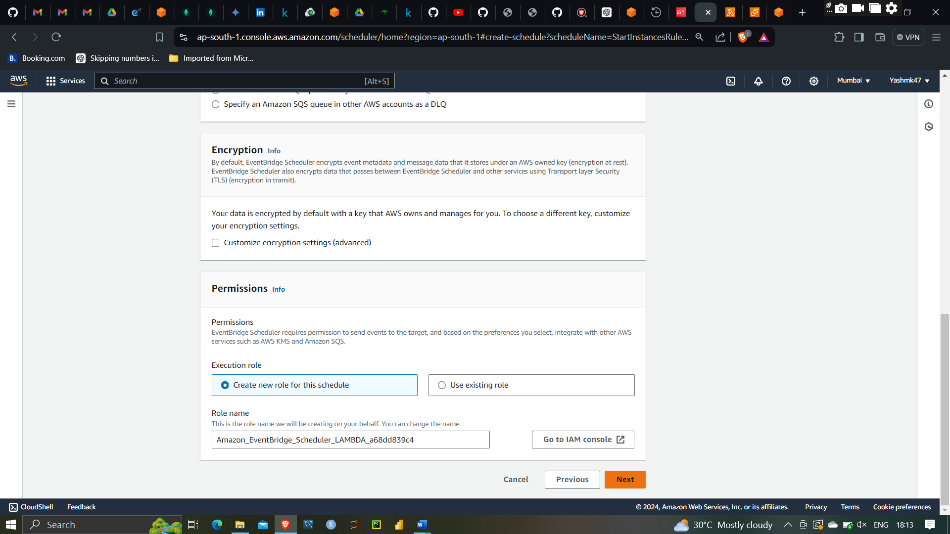

Event Bridge to start instances has schedule to 6:17 so it will start the instance at 6:17

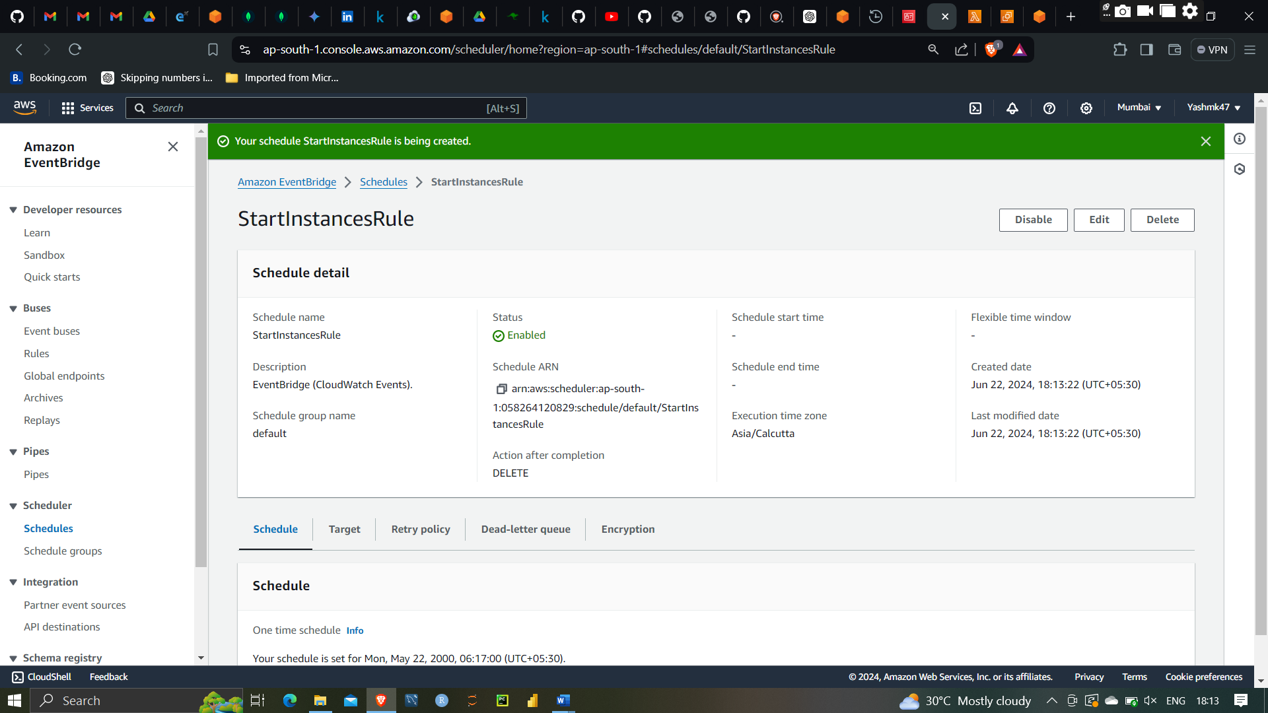

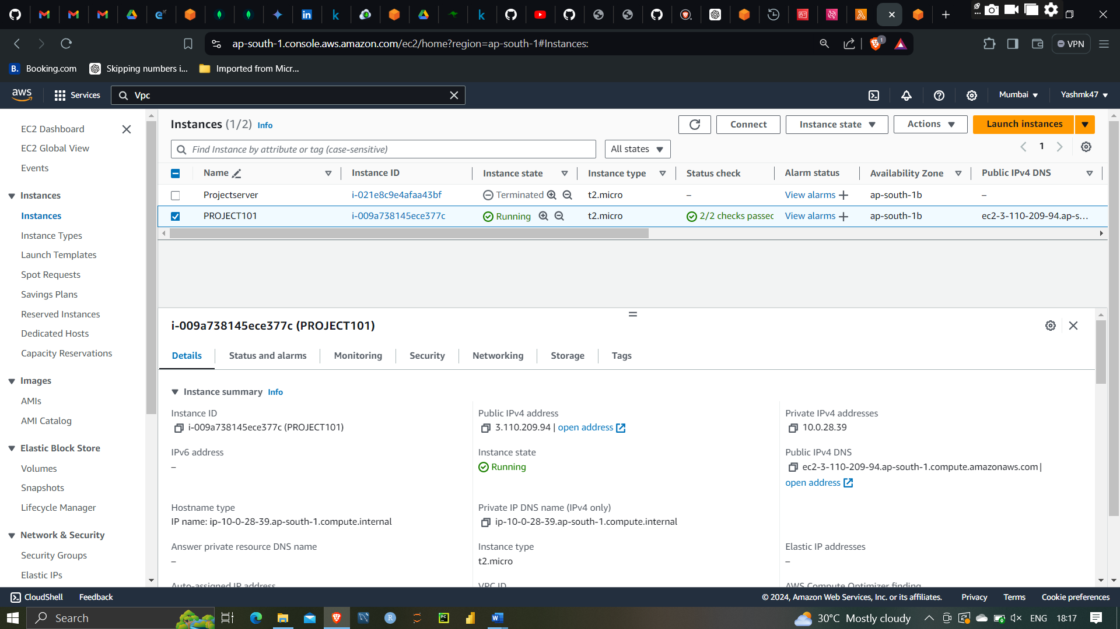

As you can see here Event has triggered the instances was stopped now it is started

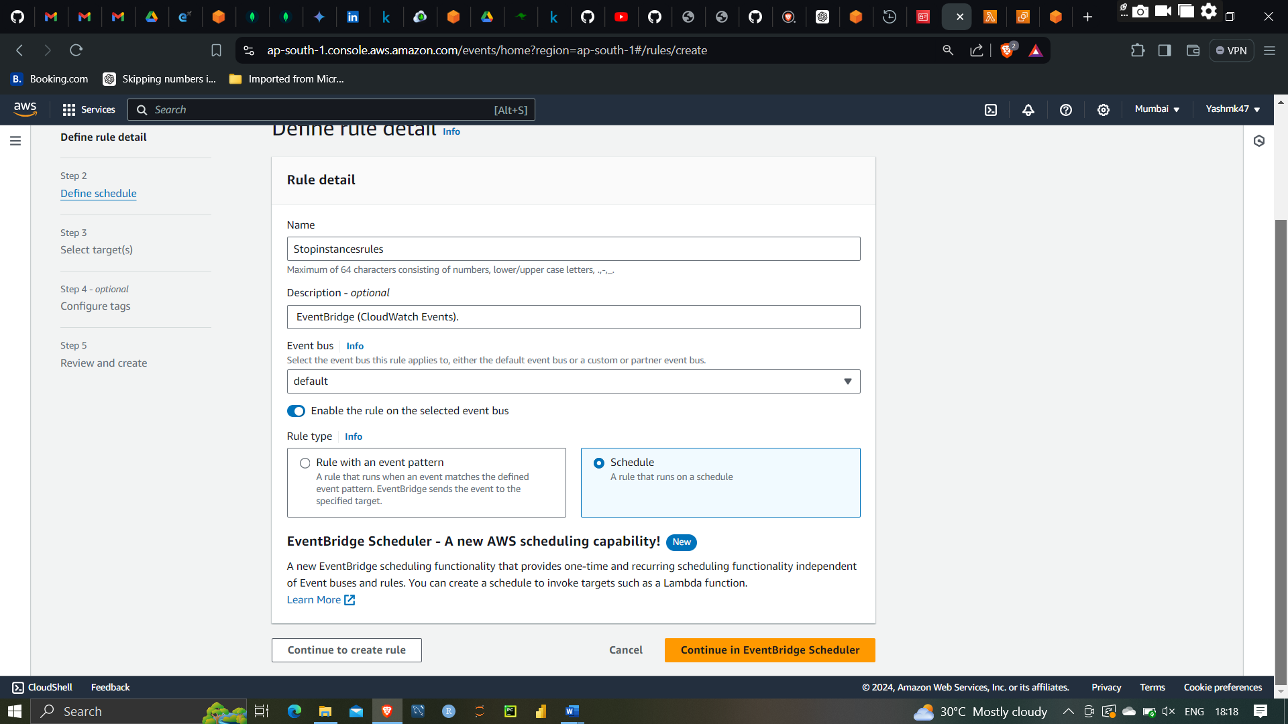

Now I will create stop instances rules

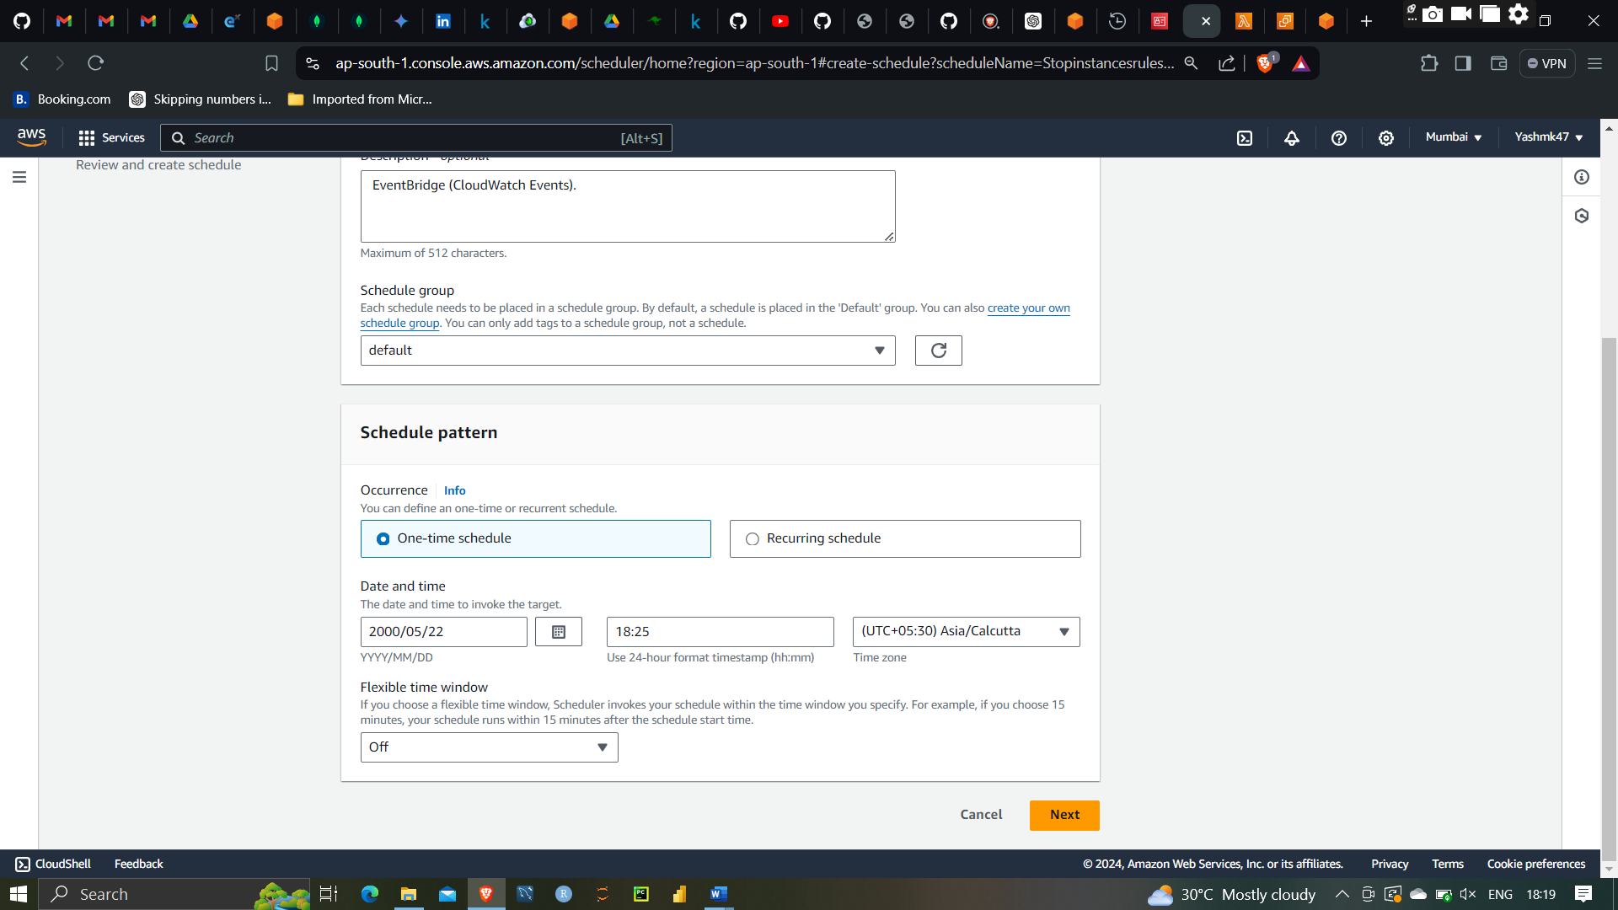

It will trigger function at 6:25 pm

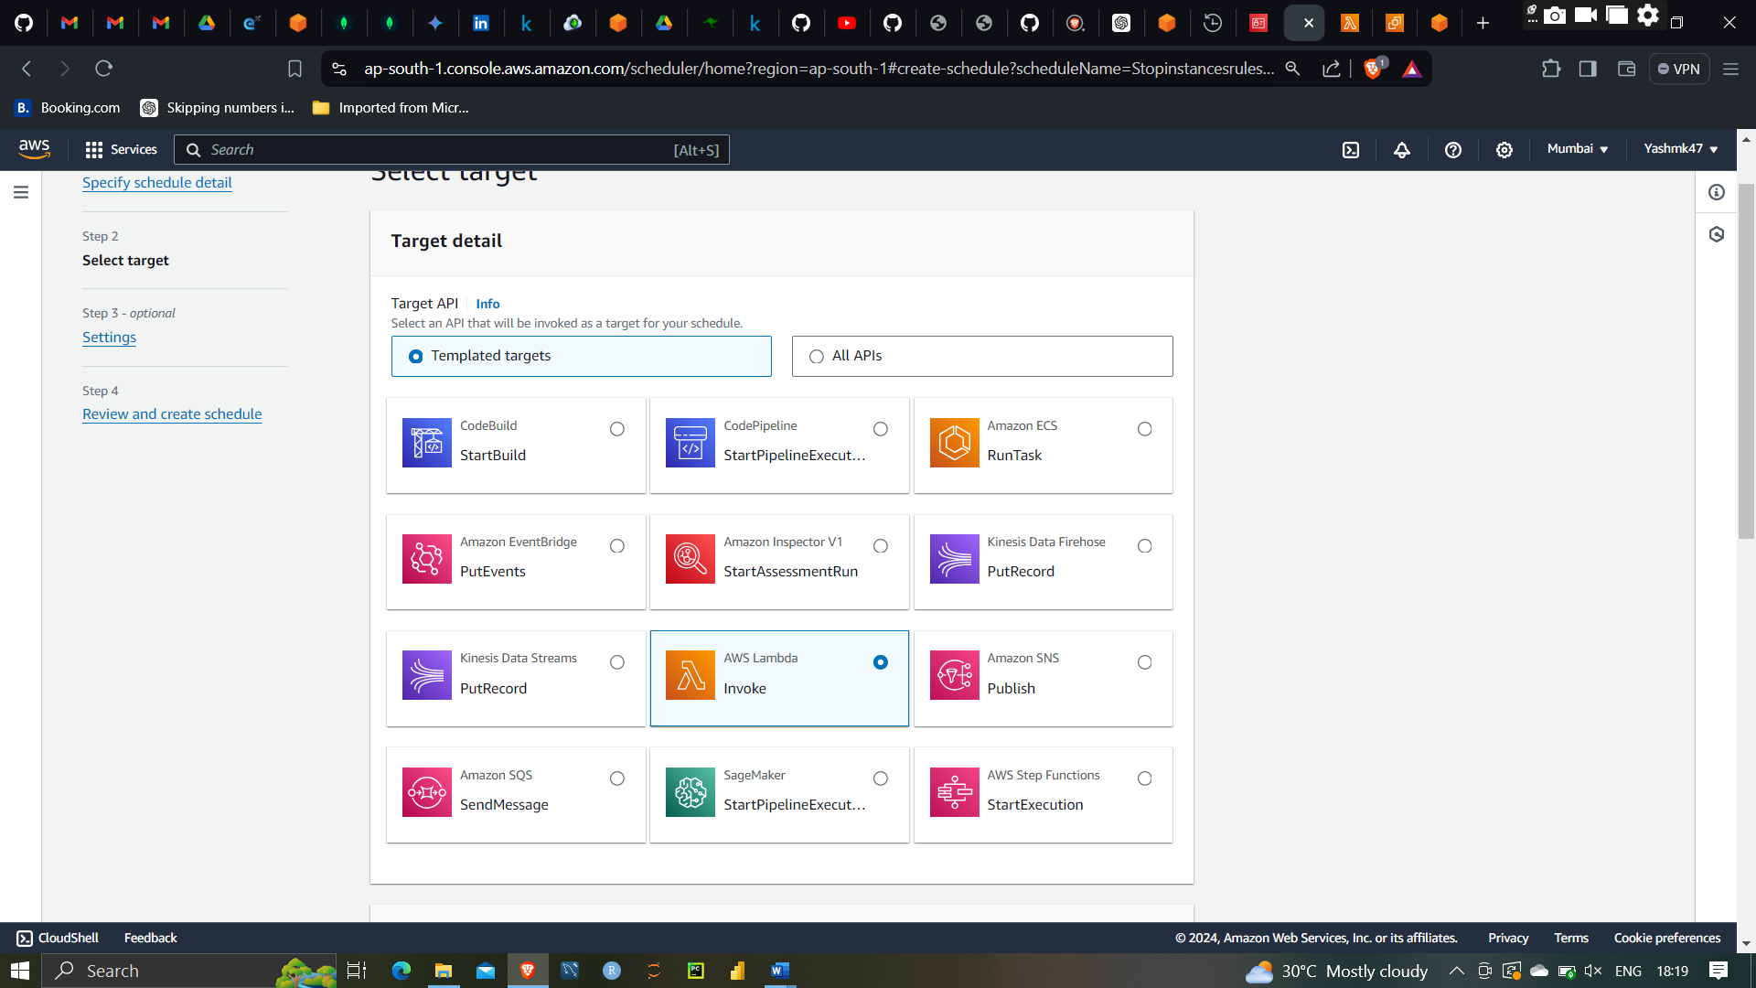

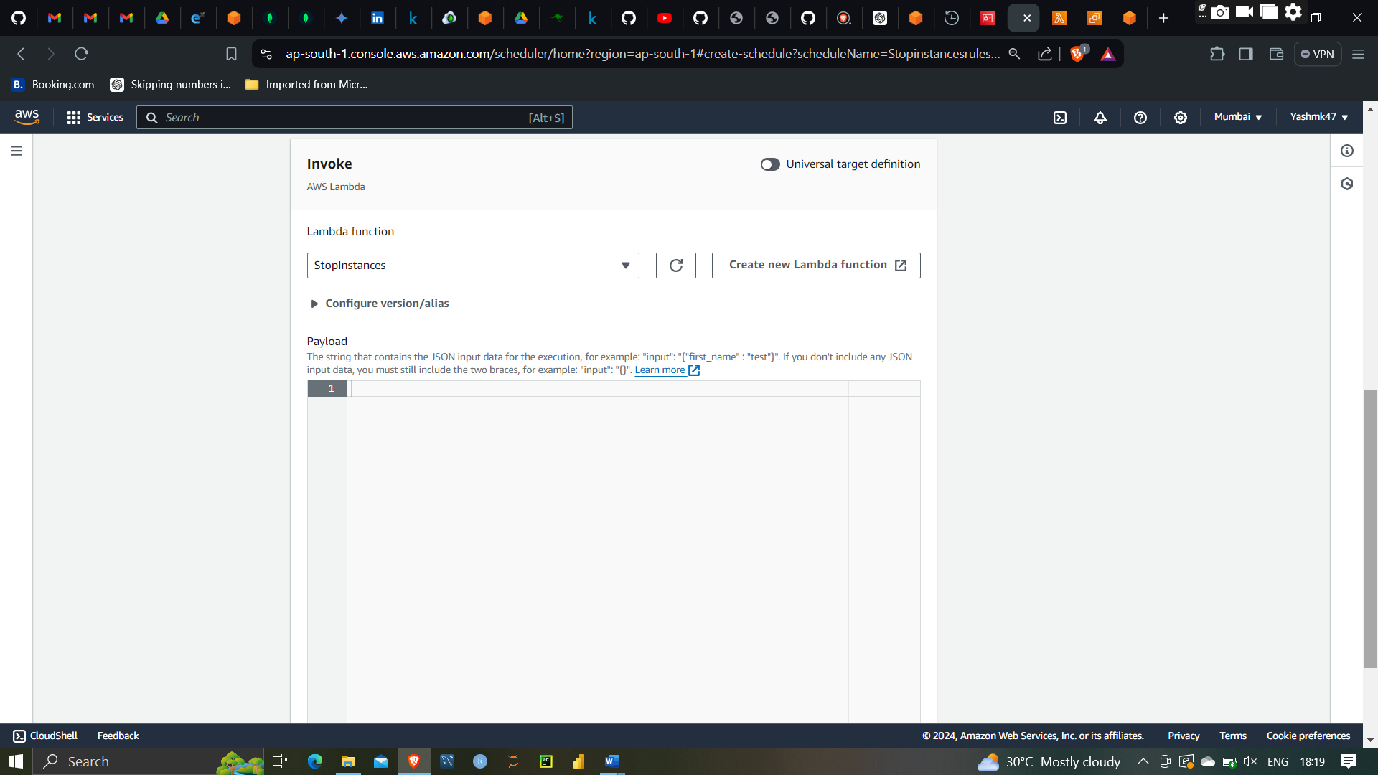

Attaching Function to the event bridge

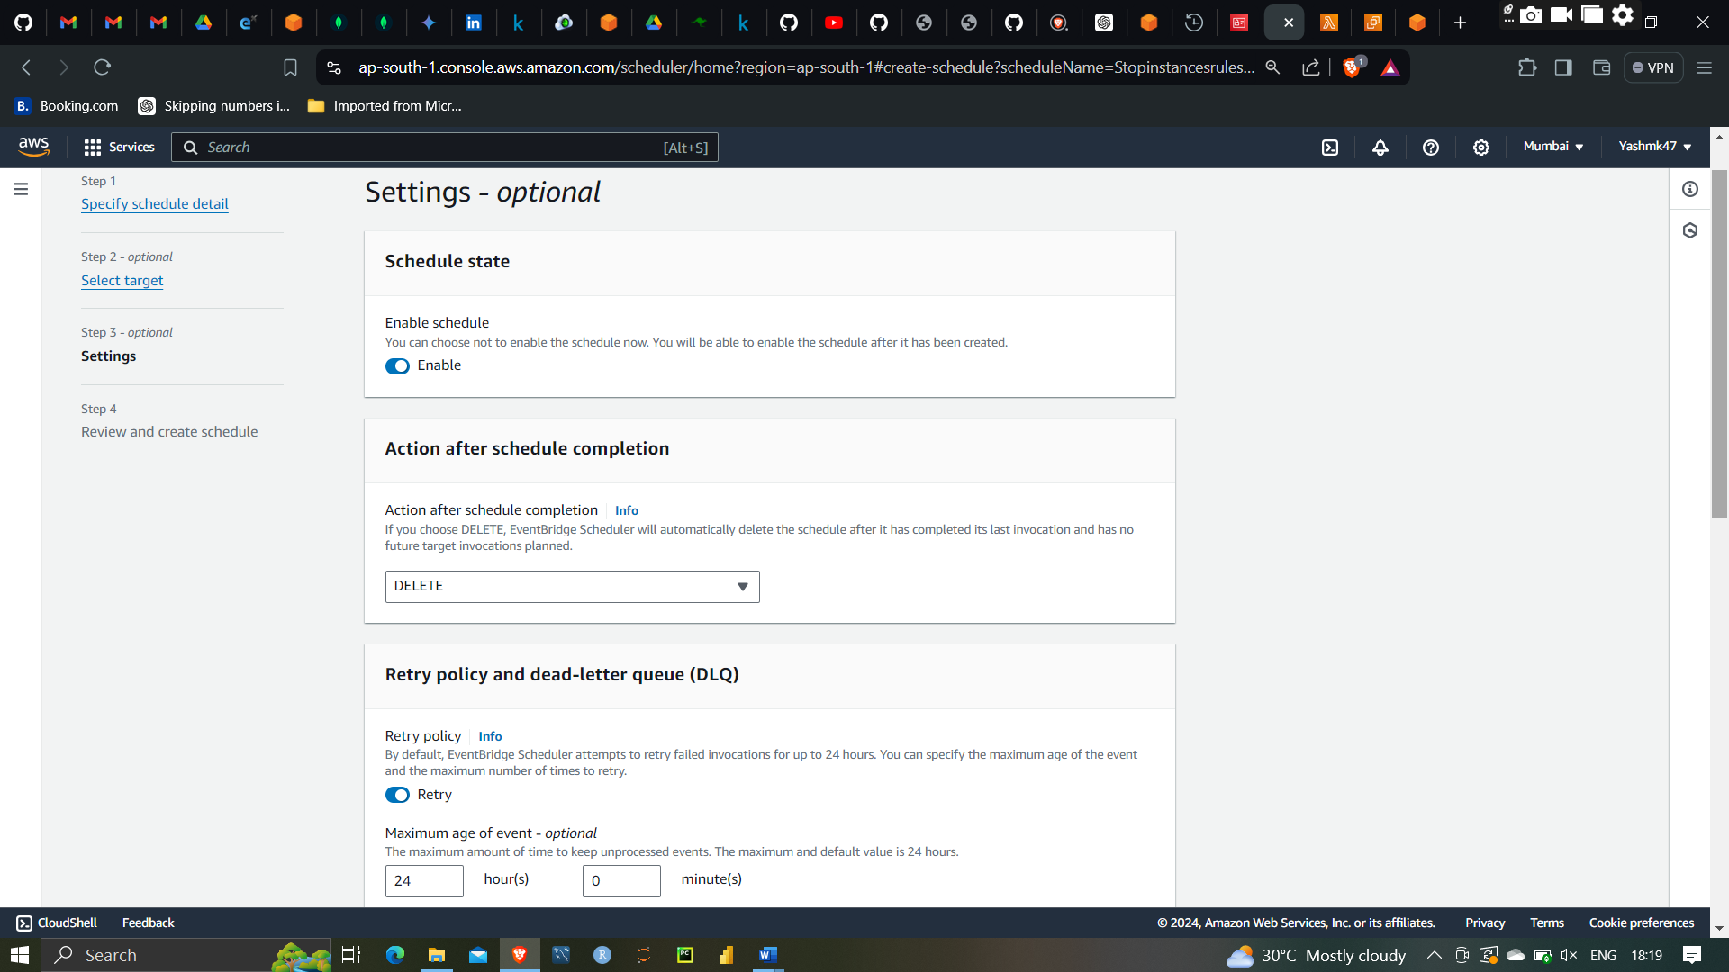

Delete after running instances ones

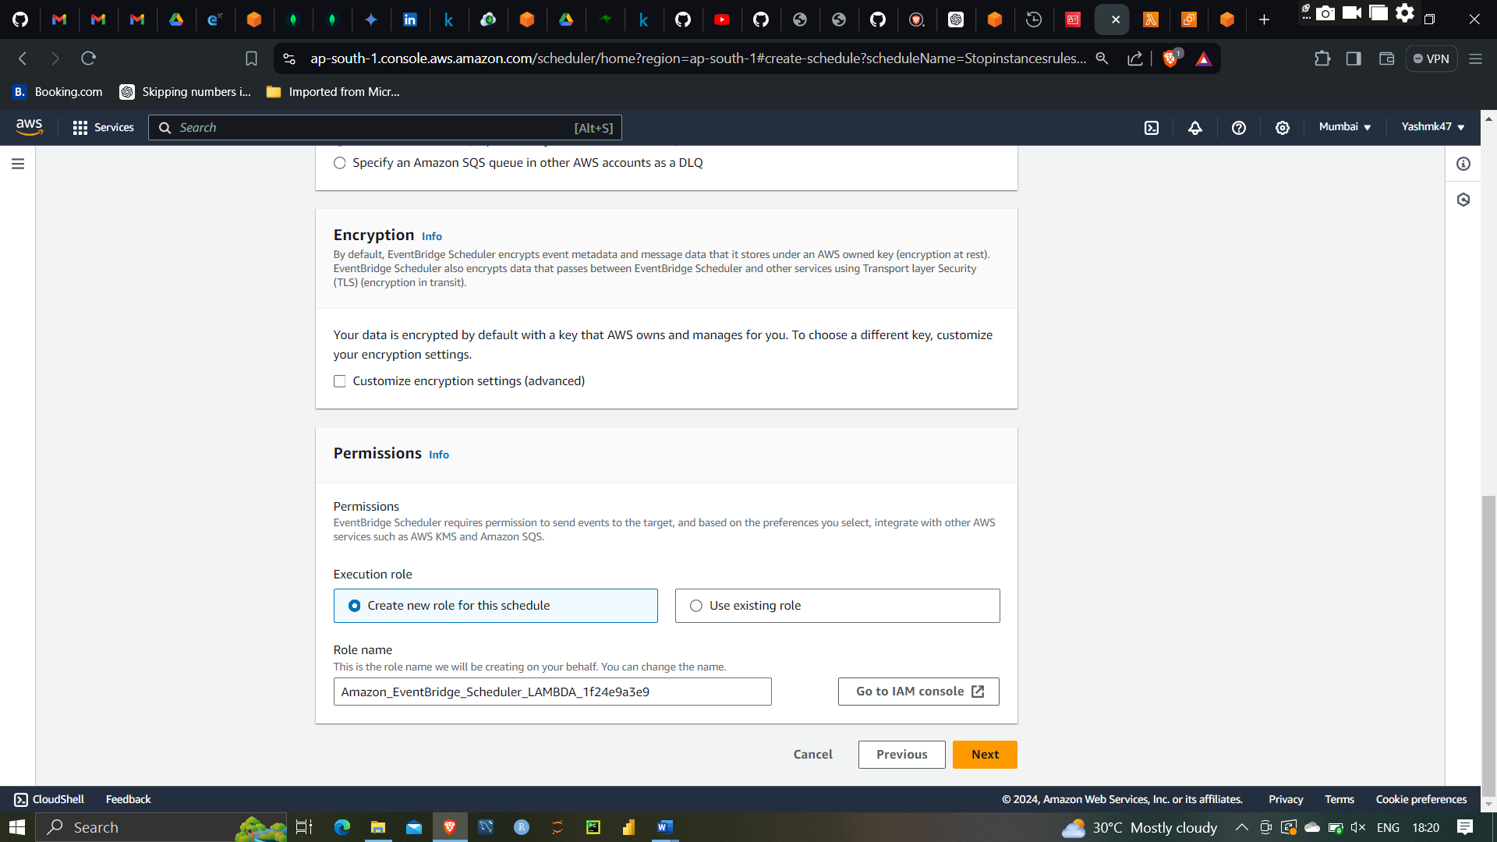

At 6:25 instances will be stopped

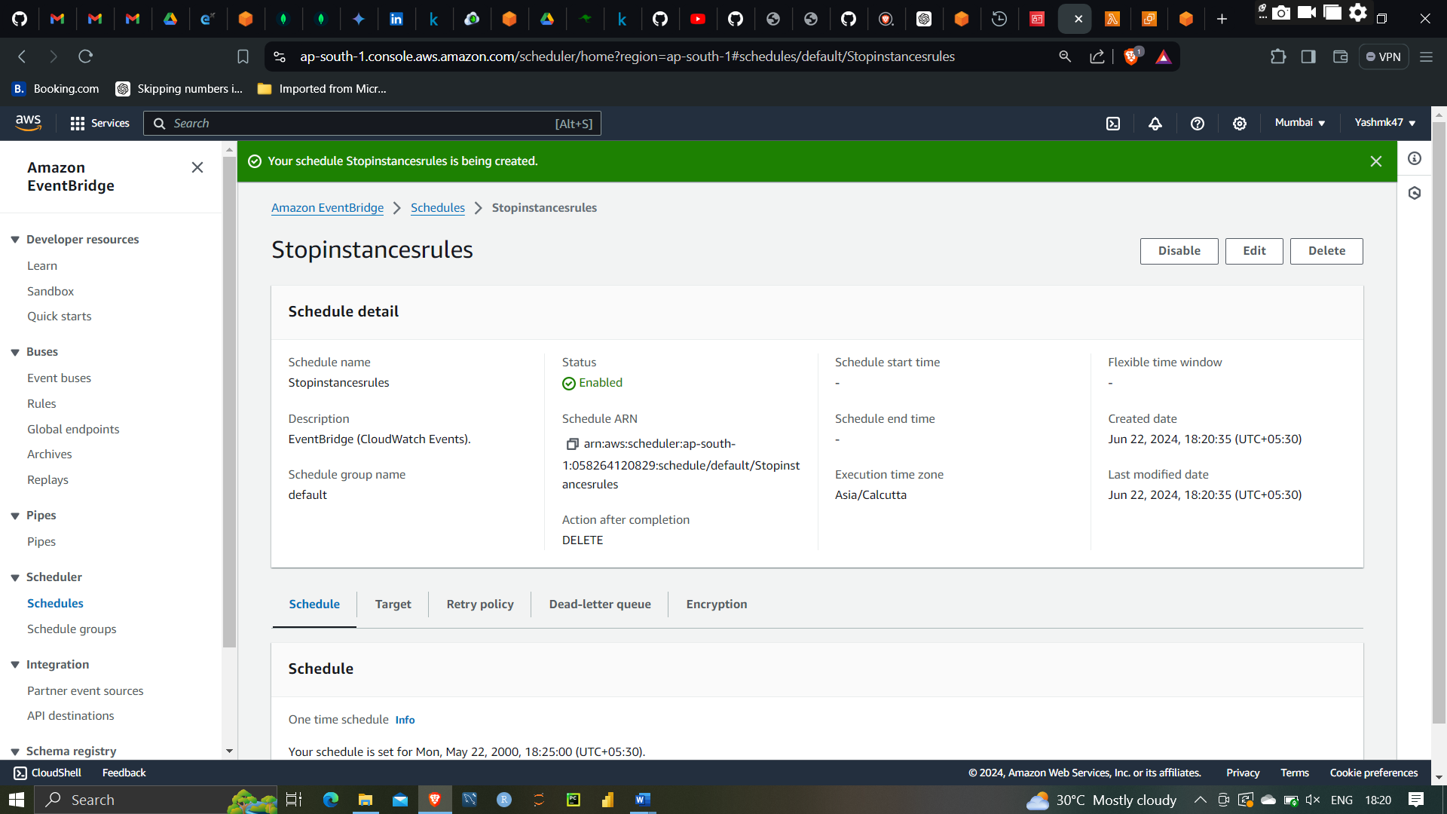

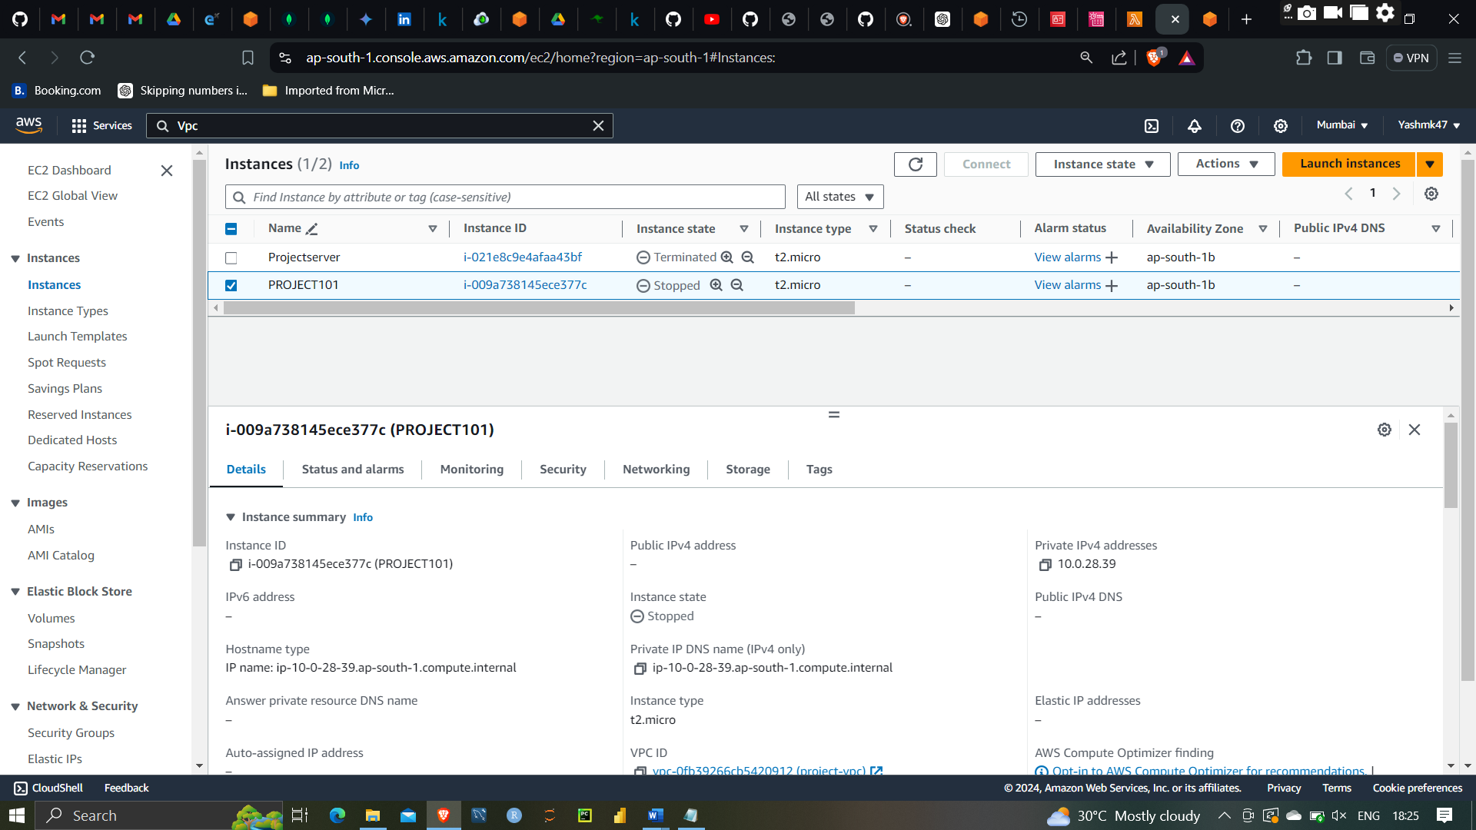

As you see here Instances has stopped here

Here there demonstration in successfully completed By the help of IAM Roles,policy ,Lambada with automatically trigger EC2 instances and with help of event bridge we can successfully automate the event(instances) at the specific timeframe